**Pharma-Network**

**Created By: Soumik Saha**

1. **Introduction**

Pharma network is a platform to tackel drug counterfiet. The Network will consist of following participant :

* Maunfacturers
* Distributors
* Retailers
* Consumers
* Transporters

This document will guide you through topics, which will help you to understand various functionalities available in this network.

* Prerequisite
* Installing Libraries
* Starting the Hyperledger fabric based Pharma Network
* Starting the Client Side REST API application
* Running the Test Cases
* Clearing the setup files to re-launch the network

1. **Prerequisite**

The application was developed using the following version of node, npm, Hyperledger fabric and docker

* Node version : v18.15.0
* NPM version : 9.5.0
* HyperLedger Fabric : 2.4
* Docker Version : 24.0.4 build 3713ee1
* Docker Compose version : v2.15.1

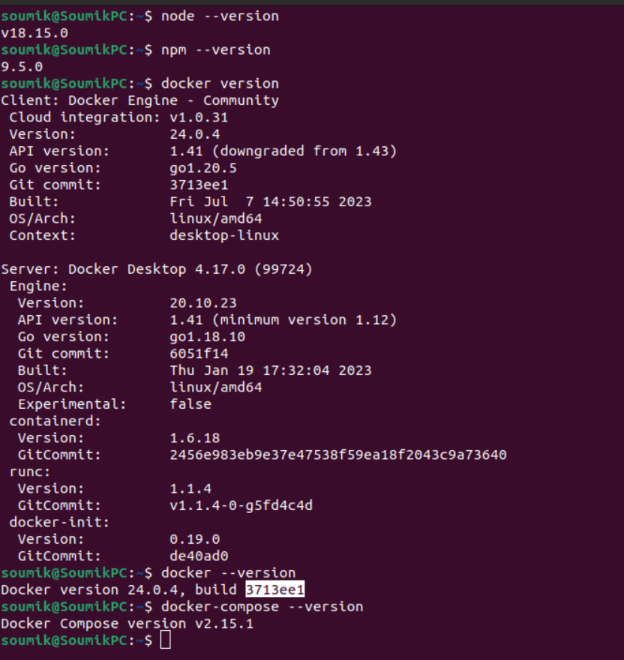

Please ensure that the prerequisite are met before going ahead with the other setup process.

1. **Installing Libraries**

**Please Note : Since, the project folder can be different based on where you have placed the project, henceforth the base path till the project folder will be denoted as {Path_to_Project} (this does not include the project folder name).**

* **Installing the Libraties for Client application :**

Once the above modules are installed, open terminal and navigate to the project folder {Path_to_Project}/pharma-network/application.

Run the command : npm install

This will install all the required libraries for the client side REST API application.

Please refer to the below image:

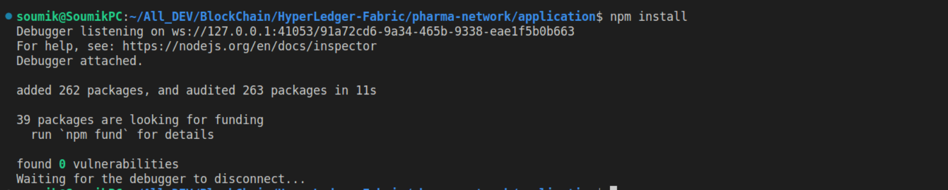

* **Installing the libraries for Chaincodes:**

To install all the libraries for chaincode, in the same terminal/new terminal, navigate to the path {Path_to_Project}/pharma-network/chaincodes.

Run the command : npm install

This will install all the required libraries for chaincodes.

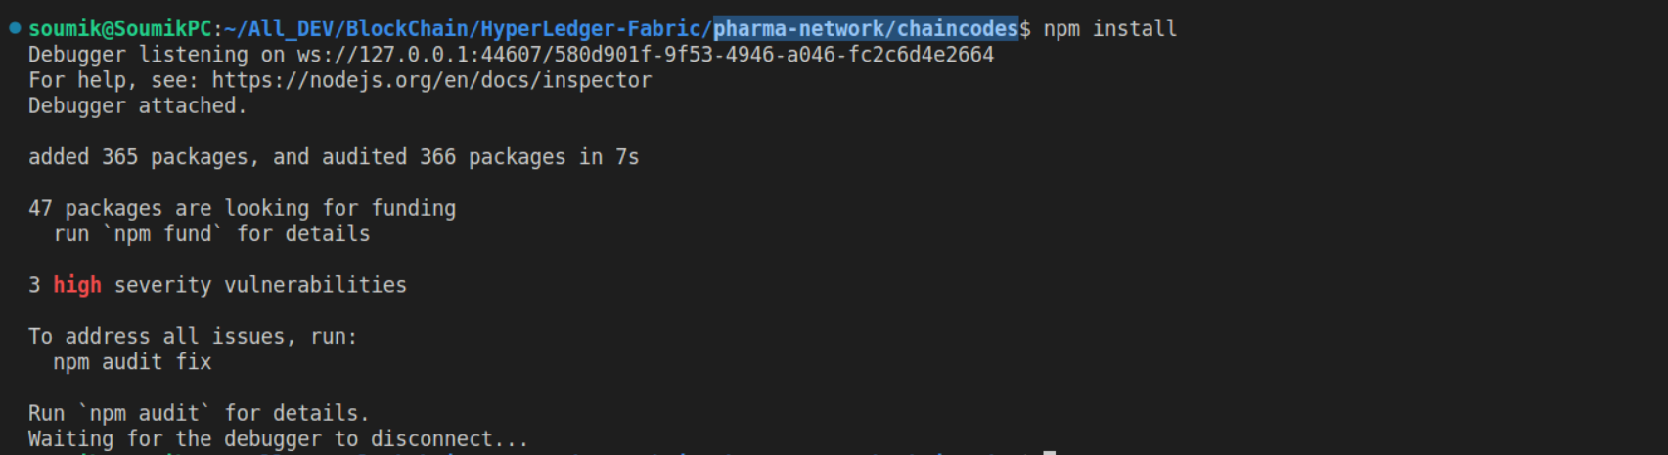

If you have reached till here, you have successfully, installed all the required libraires to run the network.

1. **Starting the Hyperledger fabric based Pharma Network**

To start the hyperledger fabric network, navigate to the folder , {Path_to_Project}/pharma-network/test-network-man

Inside this folder, you will find the following folders :-

* **AnchorPeerScripts** : This folder contains the script to create anchor peers.
* **Configtx** : Contains the configuration details for fabric network
* **Dockers**: Contains the compose files to create the required dockers
* **Organizations**: Contains the crypto libraires to create the required organizations

Also the folder contains multiple .sh scripts which are used to start the network.

**Note**, before you start to execute the shell script, please make sure that the script are executable. The simple way to do this is :-

* Open File Explorer
* Navigate to {Path_to_Project}/pharma-network/test-network-man
* Right click on the .sh files and select properties
* Select the permission tab
* On the bottom select the checkbox, Allow executing file as program.

**Note**, the above set of actions need to be done for the following set of files :-

* testFile.sh
* startNetwork.sh
* deployChaincode.sh
* create_join_Channel.sh
* clearSetup.sh

Once the above stpes are completed,we can start the network.

To start the network, please make sure that in the terminal, you are in the folder {Path_to_Project}/pharma-network/test-network-man, and run the script **./startNetwork.sh.**

This script will bring up our entire network, which includes :-

* Creating all the required crypto materials
* Starting the all CA,Orderer,Peers and Chaincode dockers
* Creating channels
* Joining the peer in the channel
* Creating anchor peers
* Initialising Chaincode
* Approving Chaincode
* Deploying Chaincode

Please find the below screenshot :-

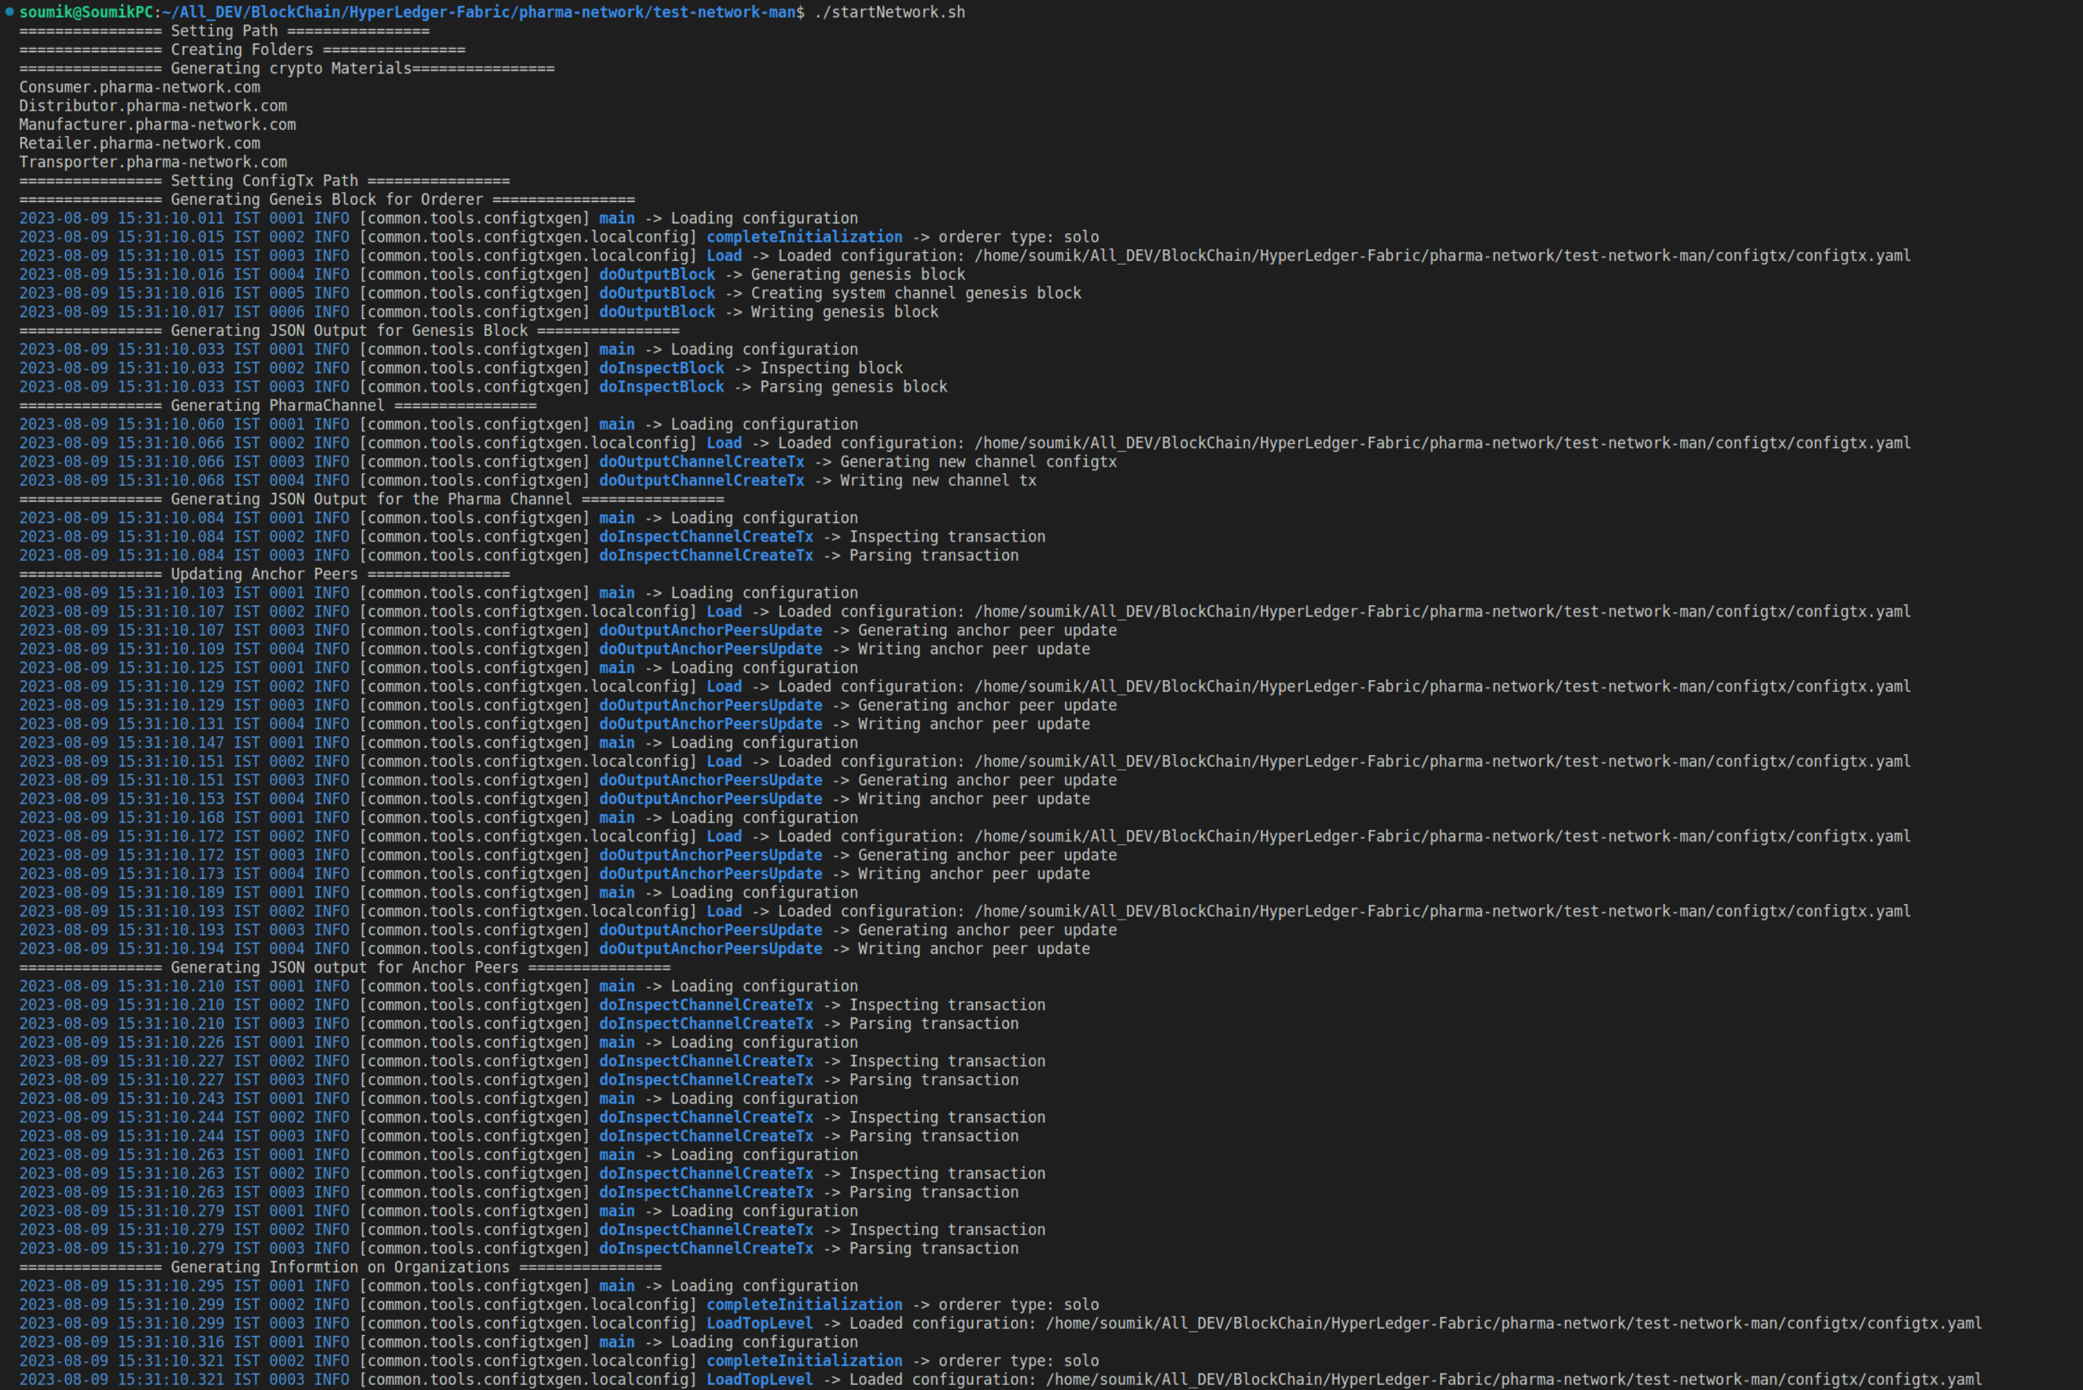

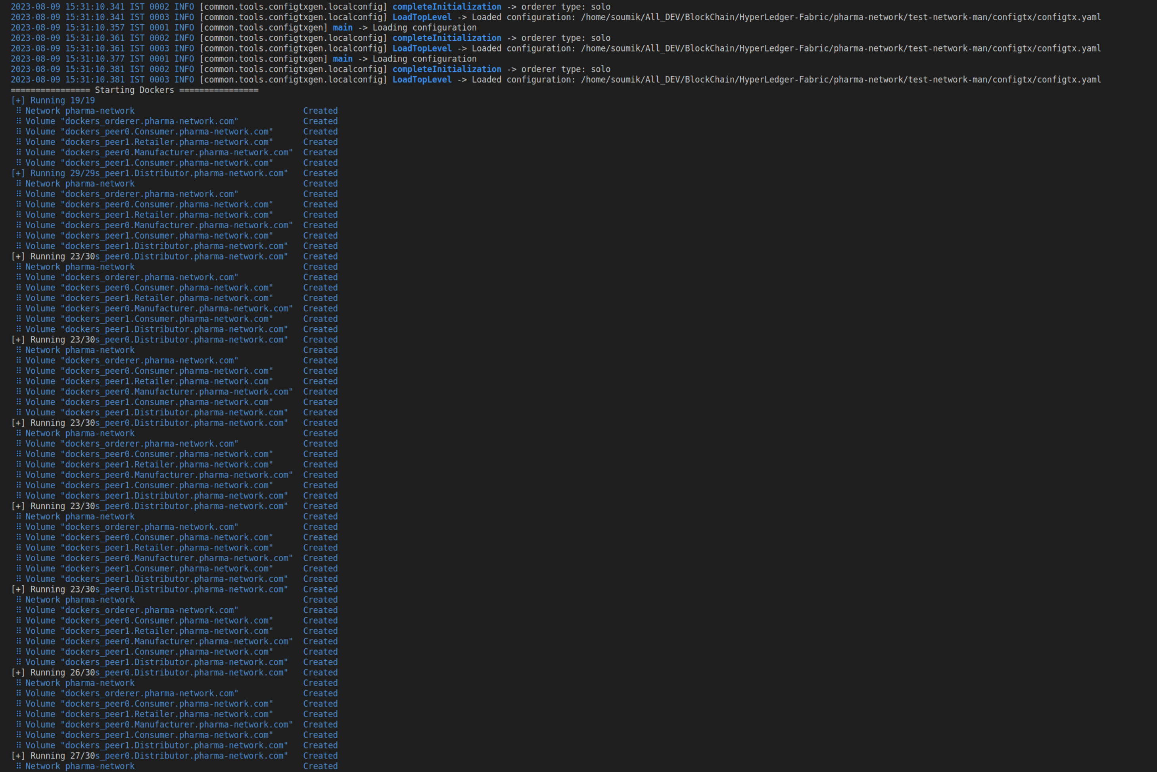

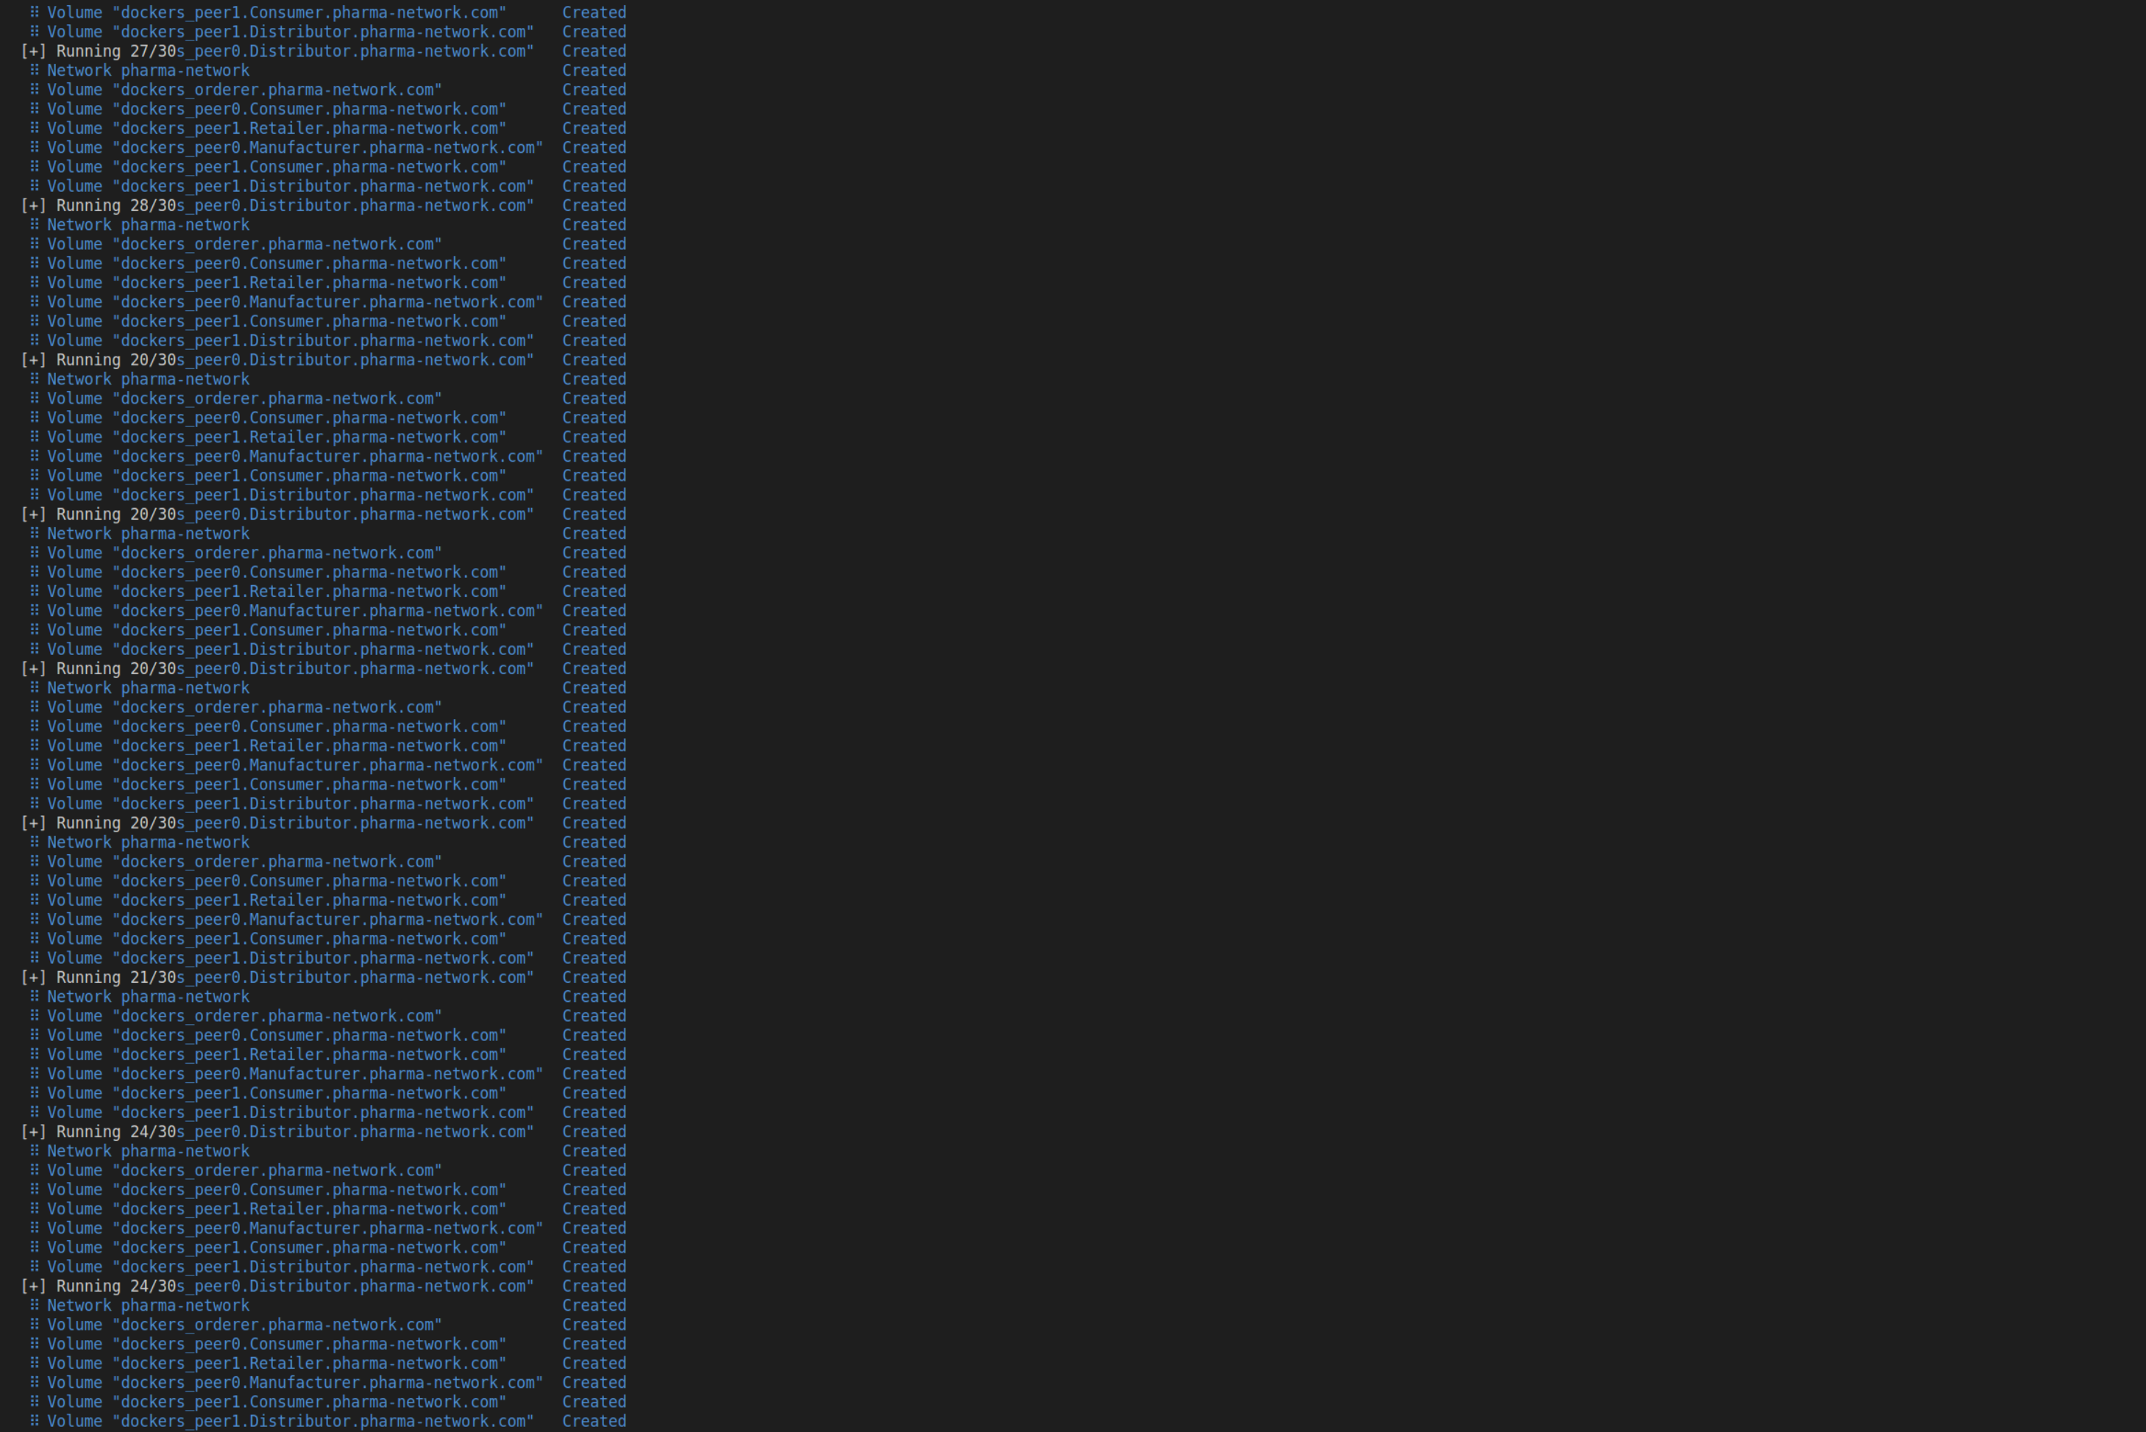

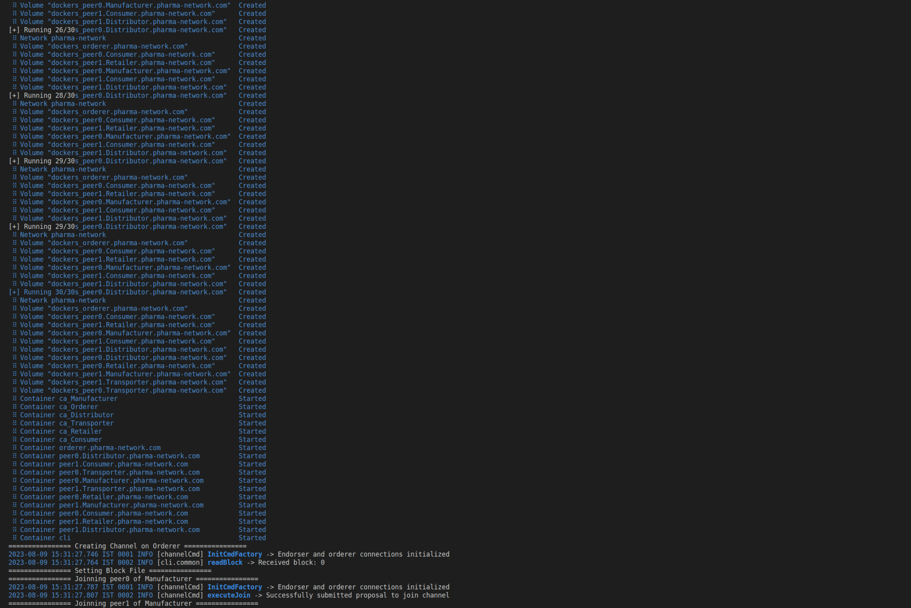

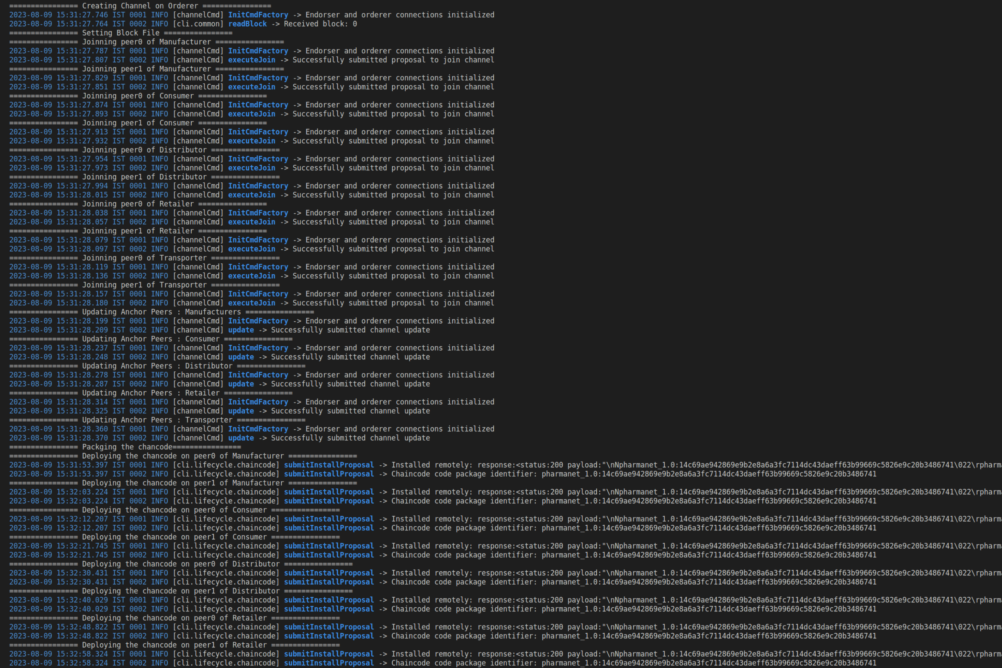

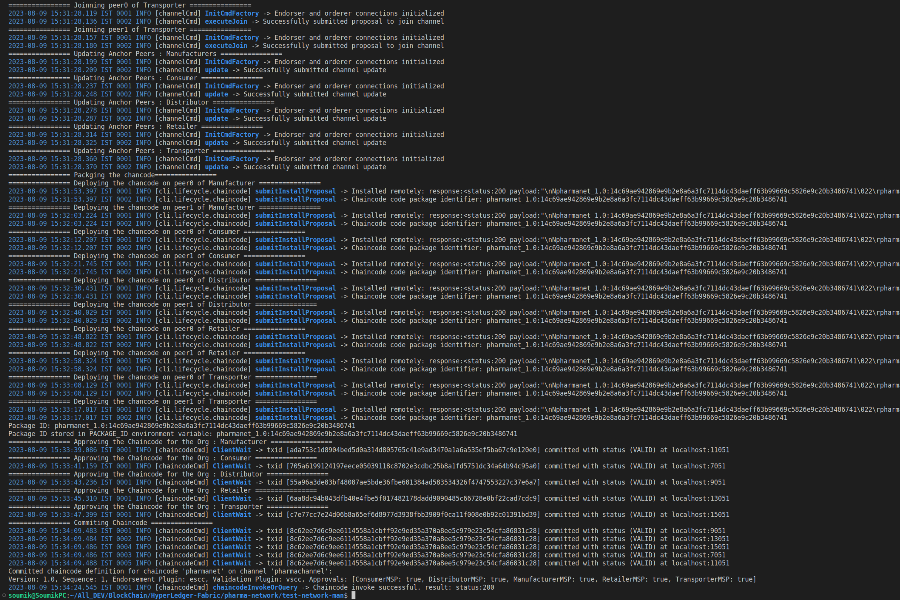

1. **Starting the Client Side REST API application**

To start the Client Side Rest API application, navigate to the path, {Path_to_Project}/pharma-network/application and run the command : **npm start**

This will bring up the Client side REST API application.

This application can be accessed in the port 3000

Pleae find the screenshot below :-

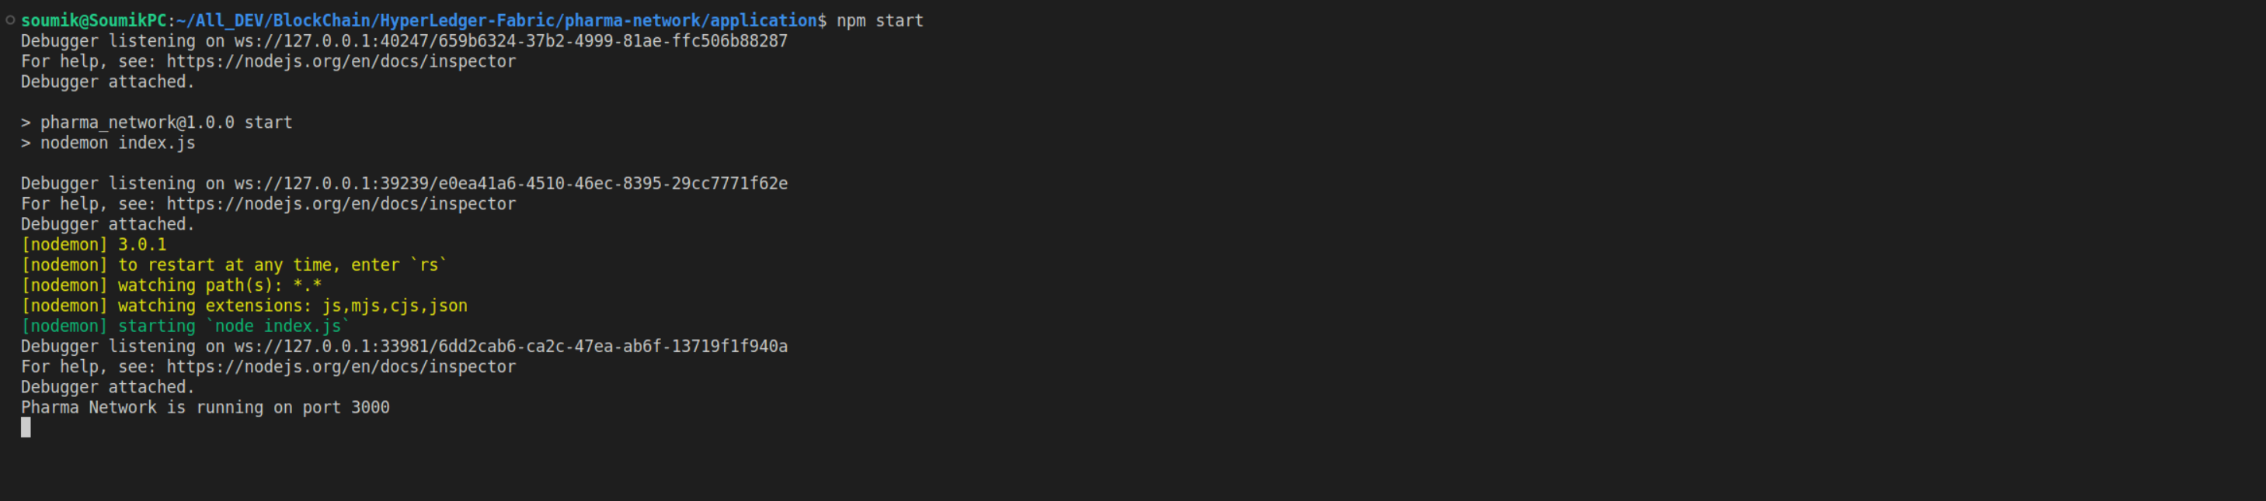

1. **Running the Test Cases**

This project contains a postman collection which contains all the necessary details to access the client side rest api and in turn interact with the underlying fabric network.

To postman collections can be found under the folder, {Path_to_Project}/pharma-network/PostMan-Collections

Please import this collection into postman.

**Note,** Output of the responses can be see from both the POSTMAN as well as in the terminal/console.

The following step will provide an walkthough on the Test Case execution :-

* Open the Setup Wallet Collection and execute the API call inside. Please note that we need to change the path of the following keys to the path present on the current system for each of the calls.

**For Consumer Wallet Setup**

* + **certificatePath**:{Path_to_Project}/pharma-network/test-network-man/organizations/peerOrganizations/Consumer.pharma-network.com/users/Admin@Consumer.pharma-network.com/msp/signcerts/Admin@Consumer.pharma-network.com-cert.pem
  + **privateKeyFilePath**:{Path_to_Project}/pharma-network/test-network-man/organizations/peerOrganizations/Consumer.pharma-network.com/users/Admin@Consumer.pharma-network.com/msp/keystore/priv_sk

**Screenshots : Postman**

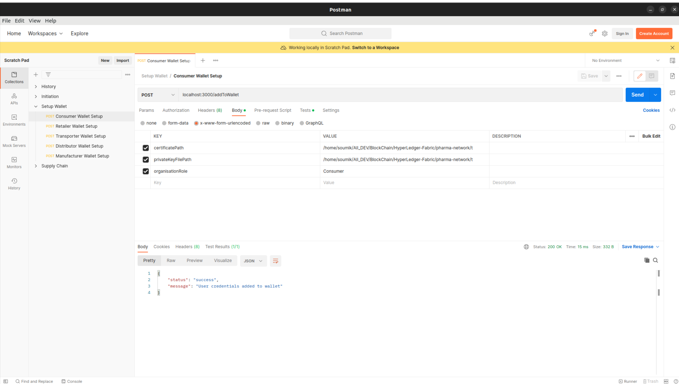

**Screenshots : Console**

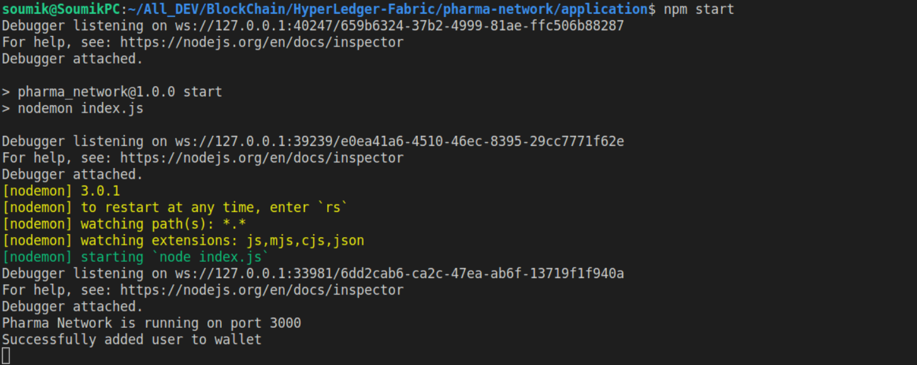

**For Retailer Wallet Setup**

* + **certificatePath**:{Path_to_Project}/pharma-network/test-network-man/organizations/peerOrganizations/Retailer.pharma-network.com/users/Admin@Retailer.pharma-network.com/msp/signcerts/Admin@Retailer.pharma-network.com-cert.pem
  + **privateKeyFilePath**:{Path_to_Project}/pharma-network/test-network-man/organizations/peerOrganizations/Retailer.pharma-network.com/users/Admin@Retailer.pharma-network.com/msp/keystore/priv_sk

**Screenshots : Postman**

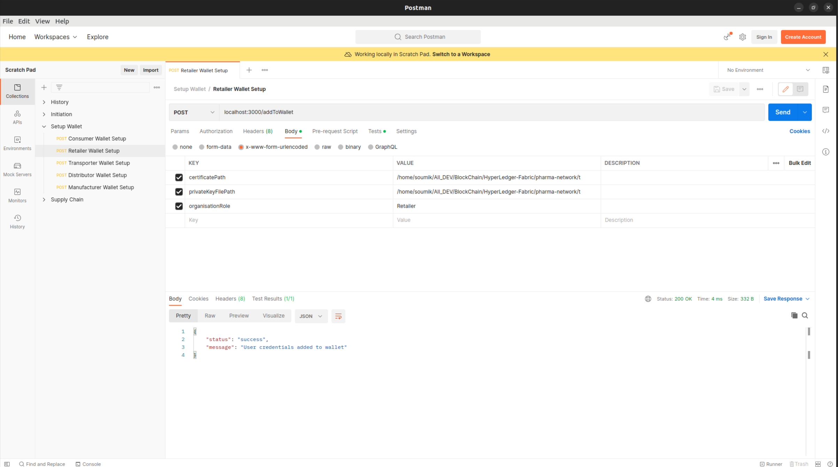

**Screenshots : Console**

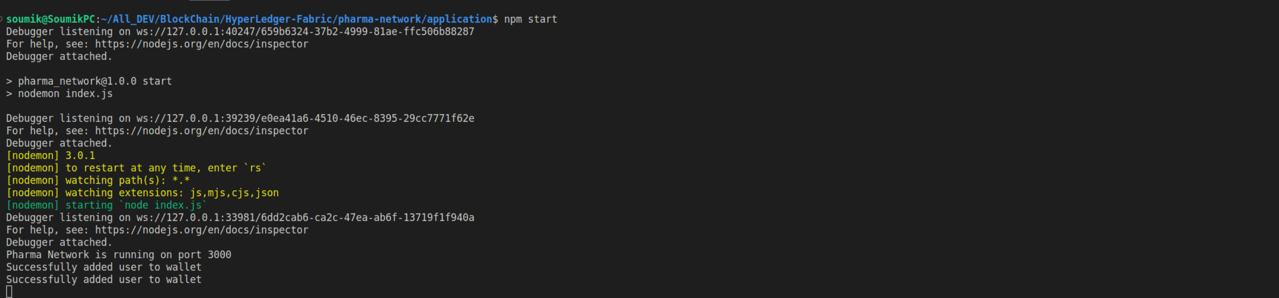

**For Manufacturer Wallet Setup**

* + **certificatePath**:{Path_to_Project}/pharma-network/test-network-man/organizations/peerOrganizations/Manufacturer.pharma-network.com/users/Admin@Manufacturer.pharma-network.com/msp/signcerts/Admin@Manufacturer.pharma-network.com-cert.pem
  + **privateKeyFilePath**:{Path_to_Project}/pharma-network/test-network-man/organizations/peerOrganizations/Manufacturer.pharma-network.com/users/Admin@Manufacturer.pharma-network.com/msp/keystore/priv_sk

**Screenshots :Postman**

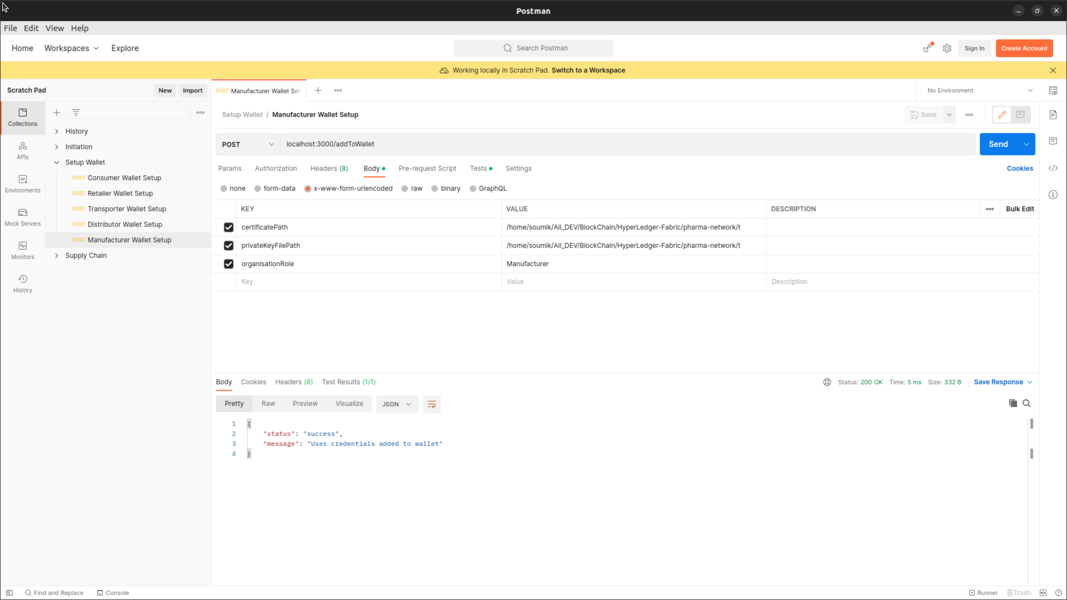

**Screenshots :Console**

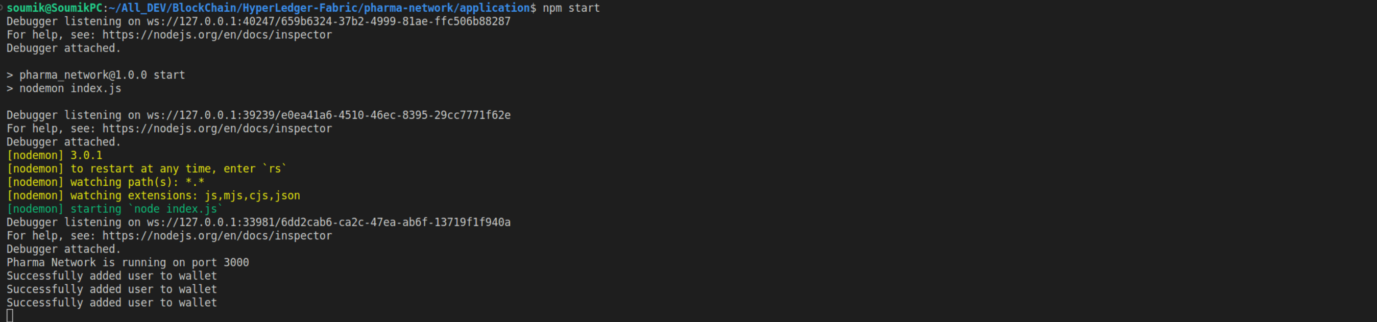

**For Distributor Wallet Setup**

* + **certificatePath**:{Path_to_Project}/pharma-network/test-network-man/organizations/peerOrganizations/Distributor.pharma-network.com/users/Admin@Distributor.pharma-network.com/msp/signcerts/Admin@Distributor.pharma-network.com-cert.pem
  + **privateKeyFilePath**:{Path_to_Project}/pharma-network/test-network-man/organizations/peerOrganizations/Distributor.pharma-network.com/users/Admin@Distributor.pharma-network.com/msp/keystore/priv_sk

**Screenshots : Postman**

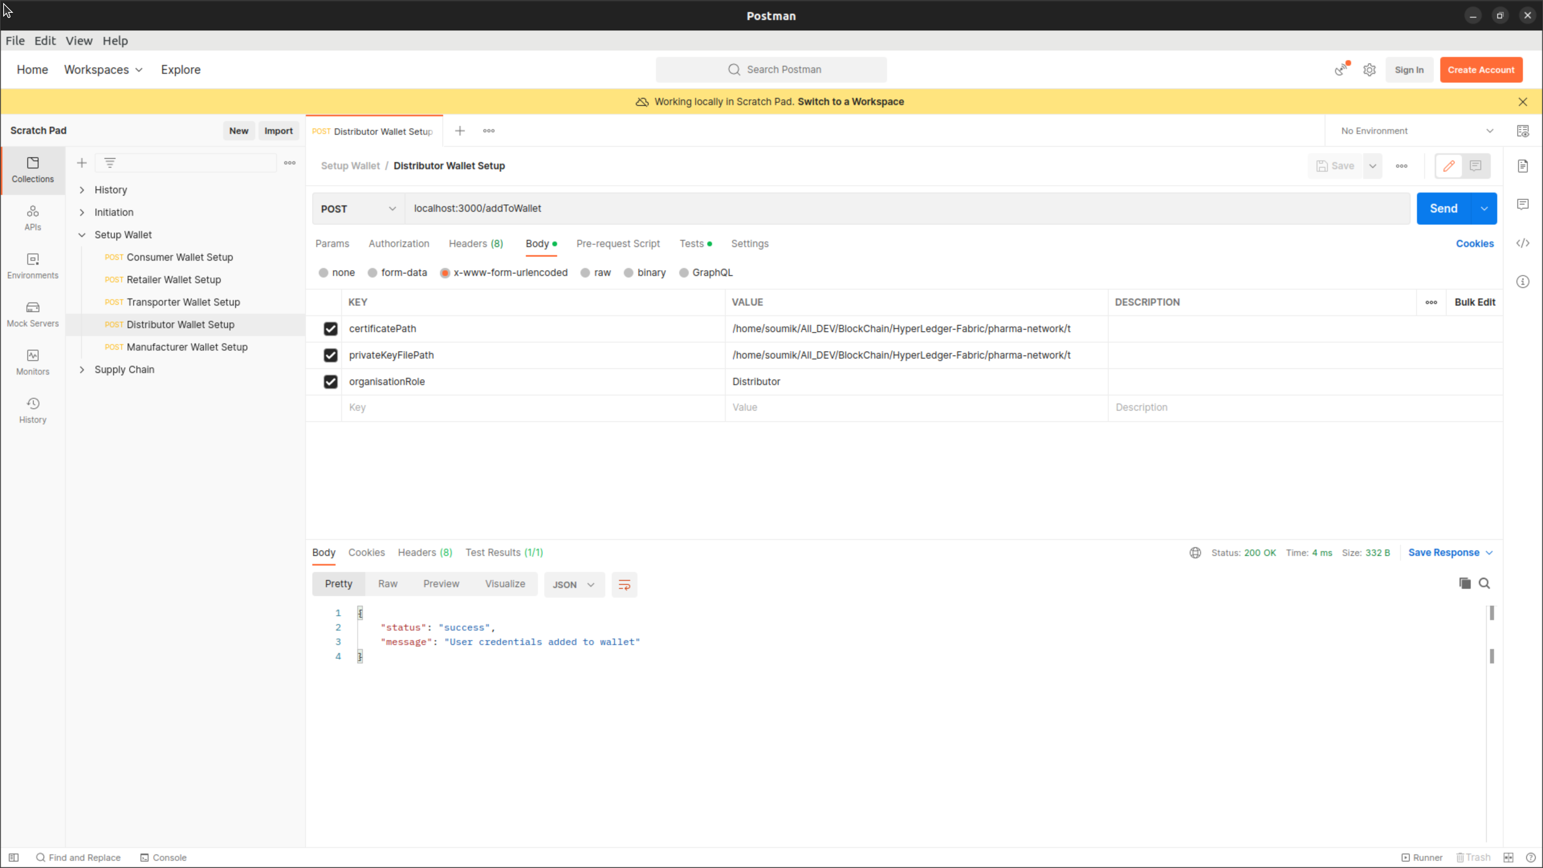

**Screenshots : Console**

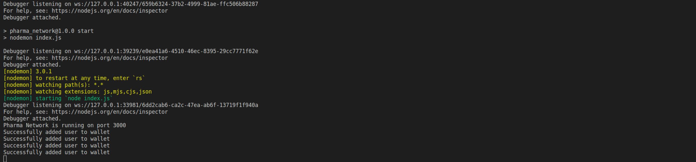

**For Transporter Wallet Setup**

* + **certificatePath**:{Path_to_Project}/pharma-network/test-network-man/organizations/peerOrganizations/Transporter.pharma-network.com/users/Admin@Transporter.pharma-network.com/msp/signcerts/Admin@Transporter.pharma-network.com-cert.pem
  + **privateKeyFilePath**:{Path_to_Project}/pharma-network/test-network-man/organizations/peerOrganizations/Transporter.pharma-network.com/users/Admin@Transporter.pharma-network.com/msp/keystore/priv_sk

**Screenshots : Postman**

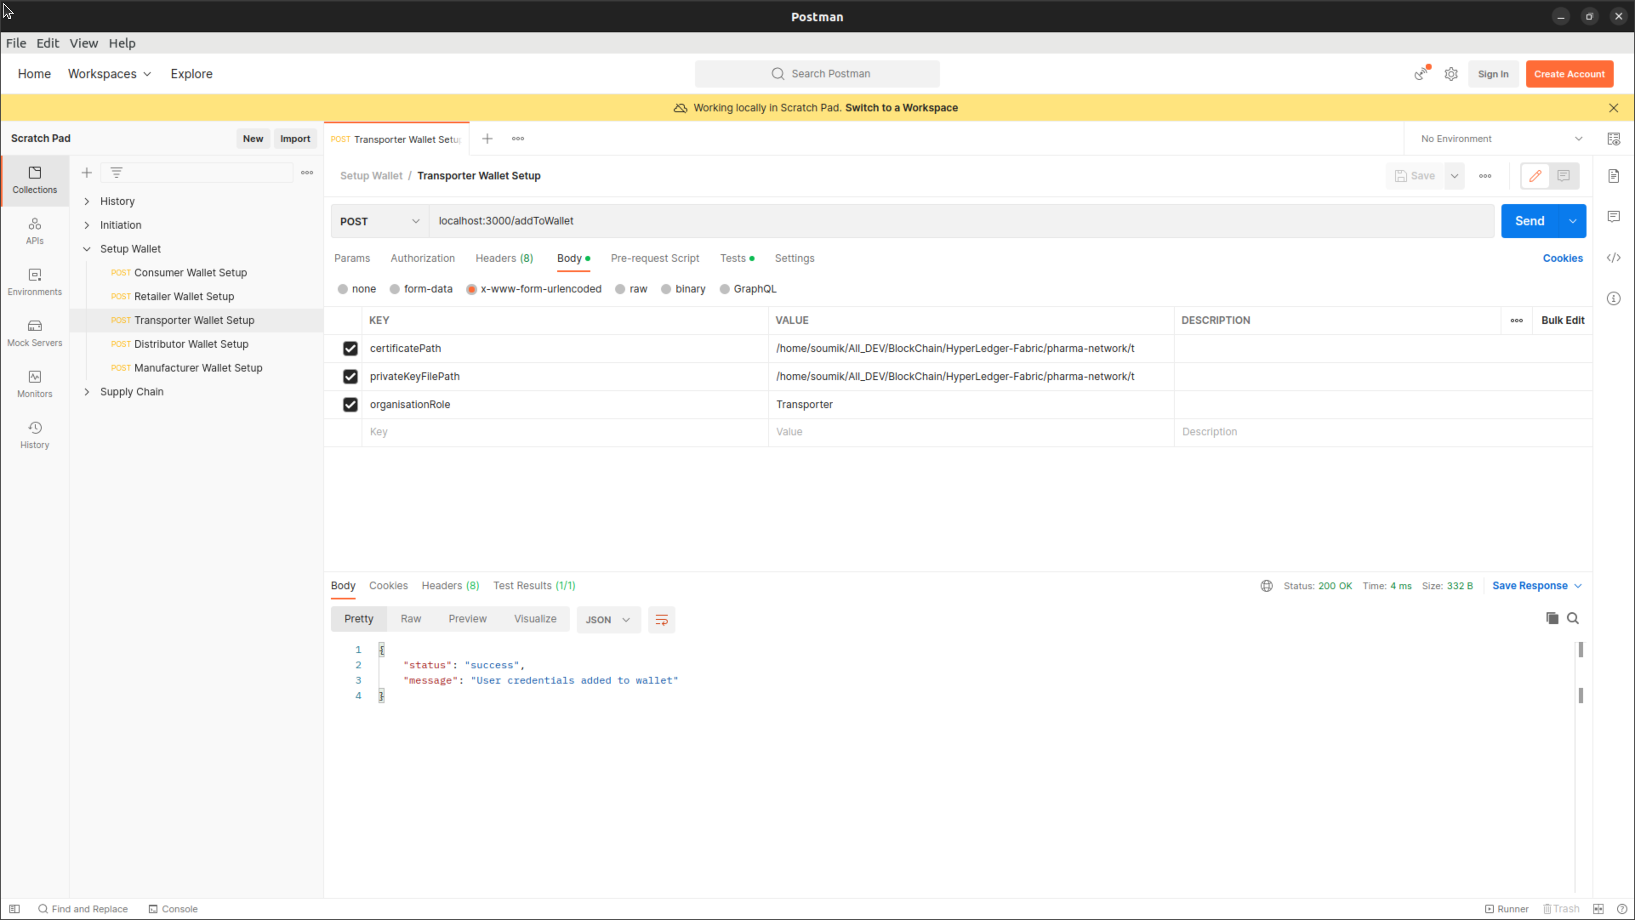

**Screenshots : Console**

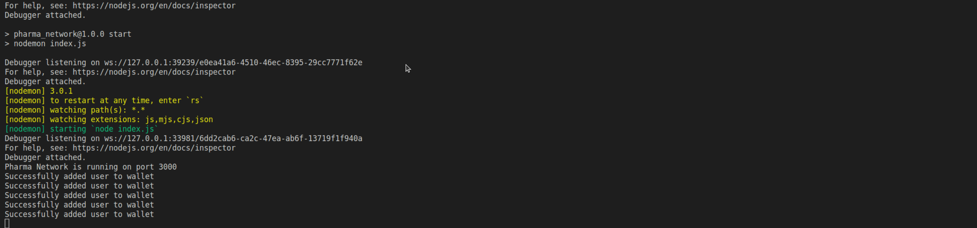

Once all the wallet transactions are completed, you can view the identity files created in the system under the folder {Path_to_Project}/pharma-network/application/identity/Orgs

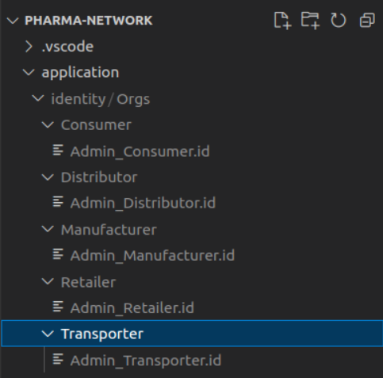

* Once the wallet creation is completed, we can move forward to register the companies and the drug. Open the Collection Initiation. This collection contains all the API call to register company and drug

**Create Company : Manufacturer**

**Screenshots : Postman**

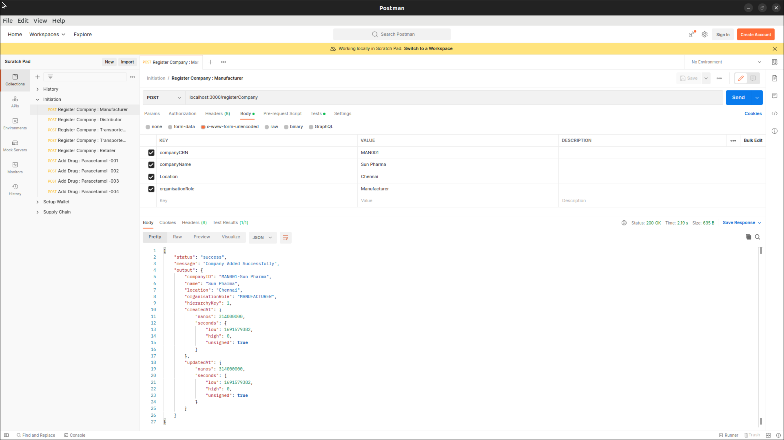

**Screenshots : Console**

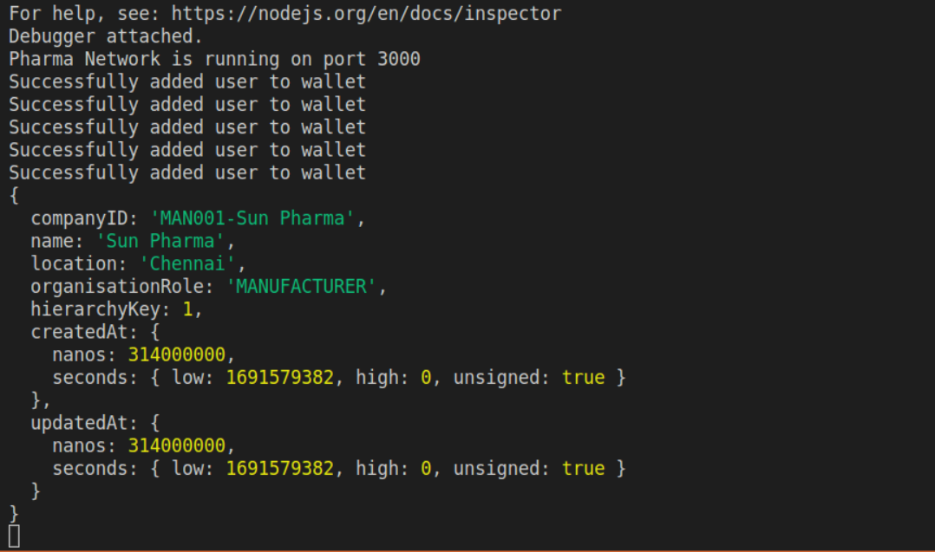

**Create Company : Distributor**

**Screenshots : Postman**

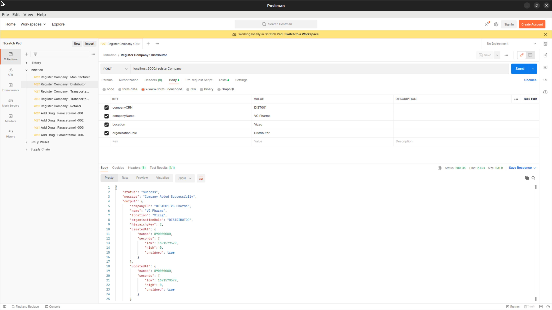

**Screenshots : Console**

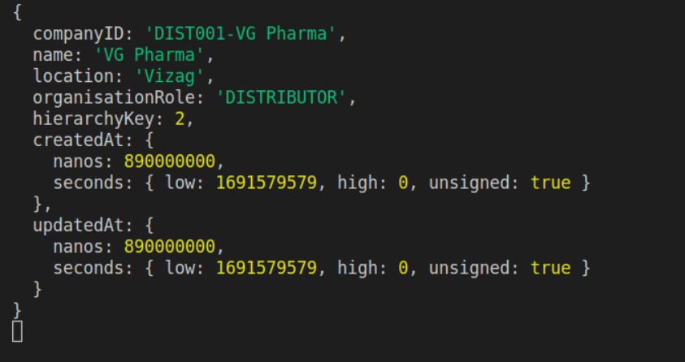

**Create Company : Transporter – FedEX**

**Screenshots : Postman**

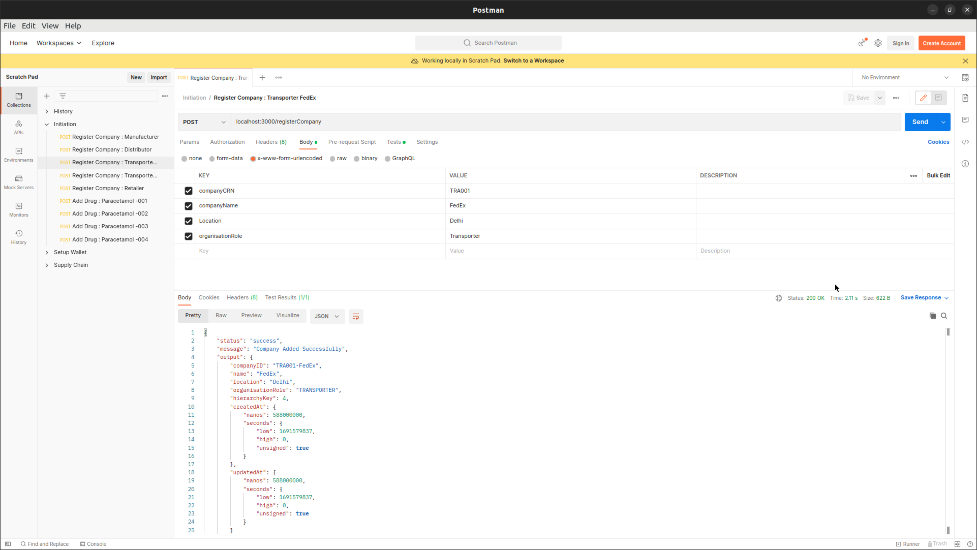

**Screenshots : Console**

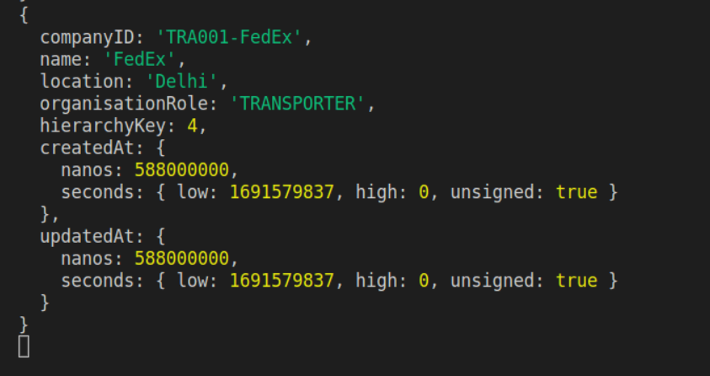

**Create Company : Transporter – Blue Dart**

**Screenshots : Postman**

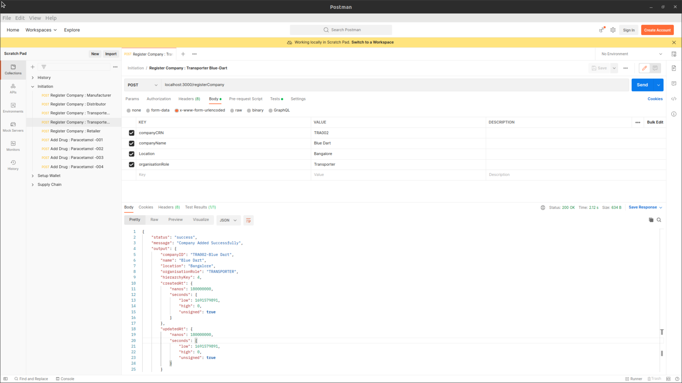

**Screenshots : Console**

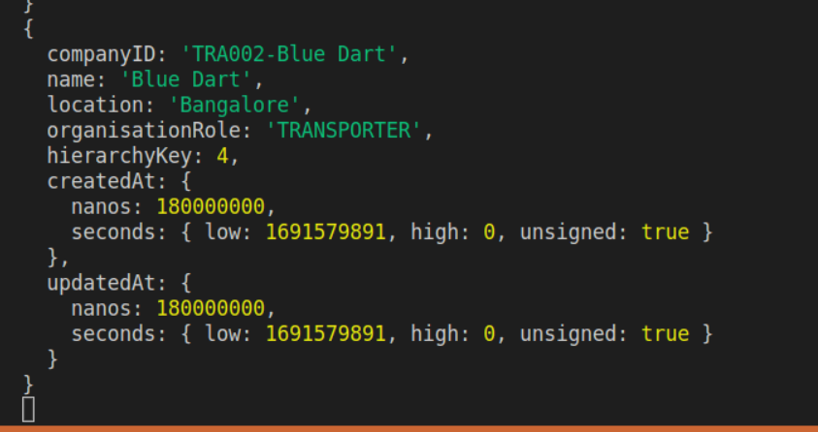

**Create Company : Retailer**

**Screenshots : Postman**

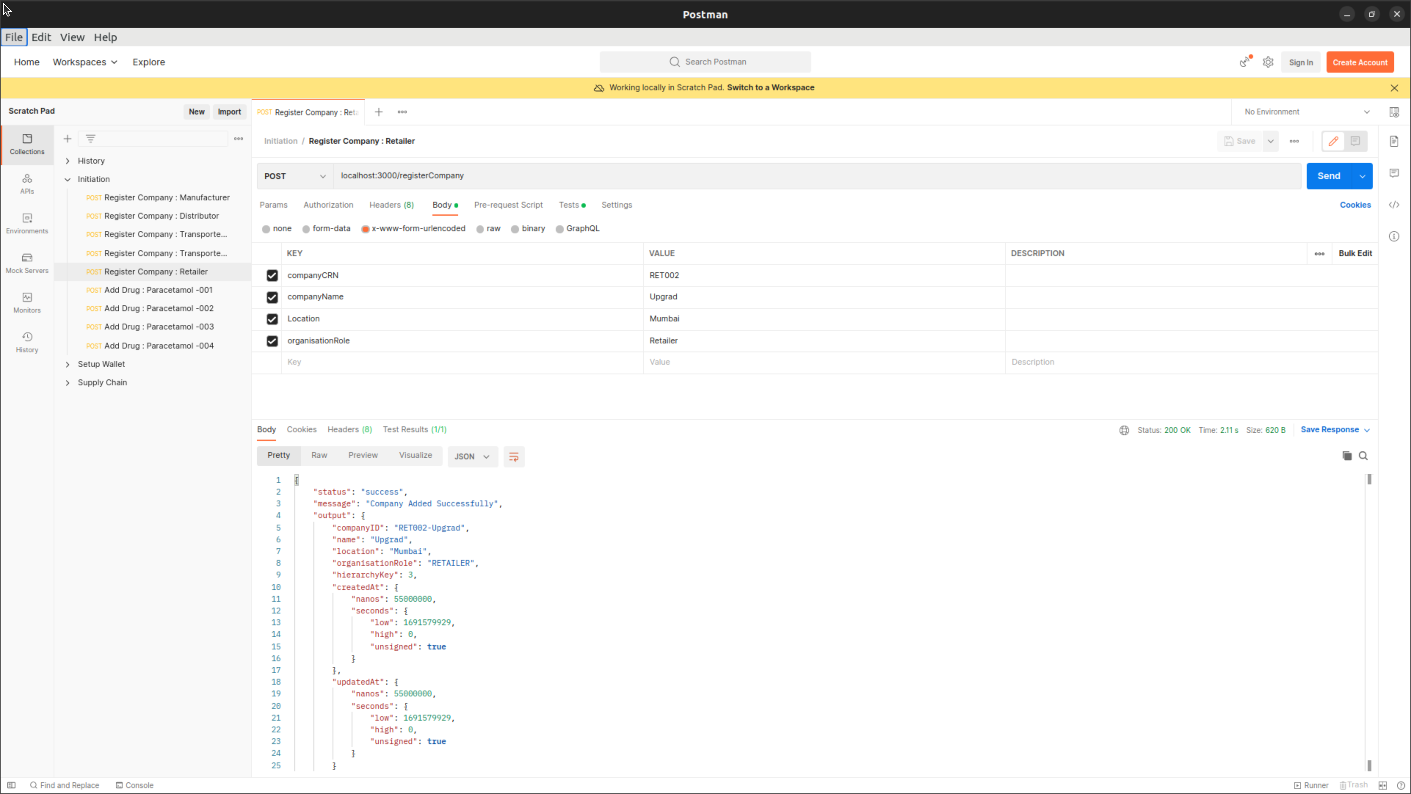

**Screenshots : Console**

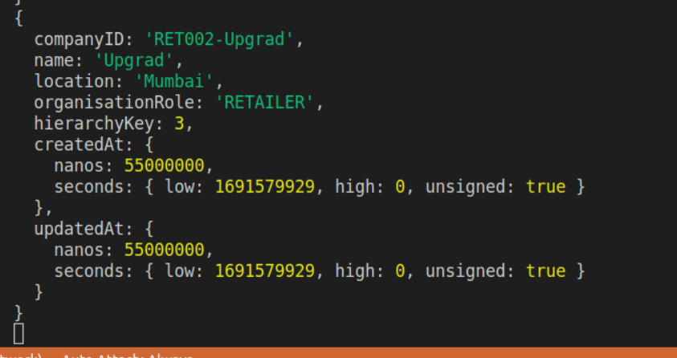

**Add Drug: 001**

**Screenshot: Postman**

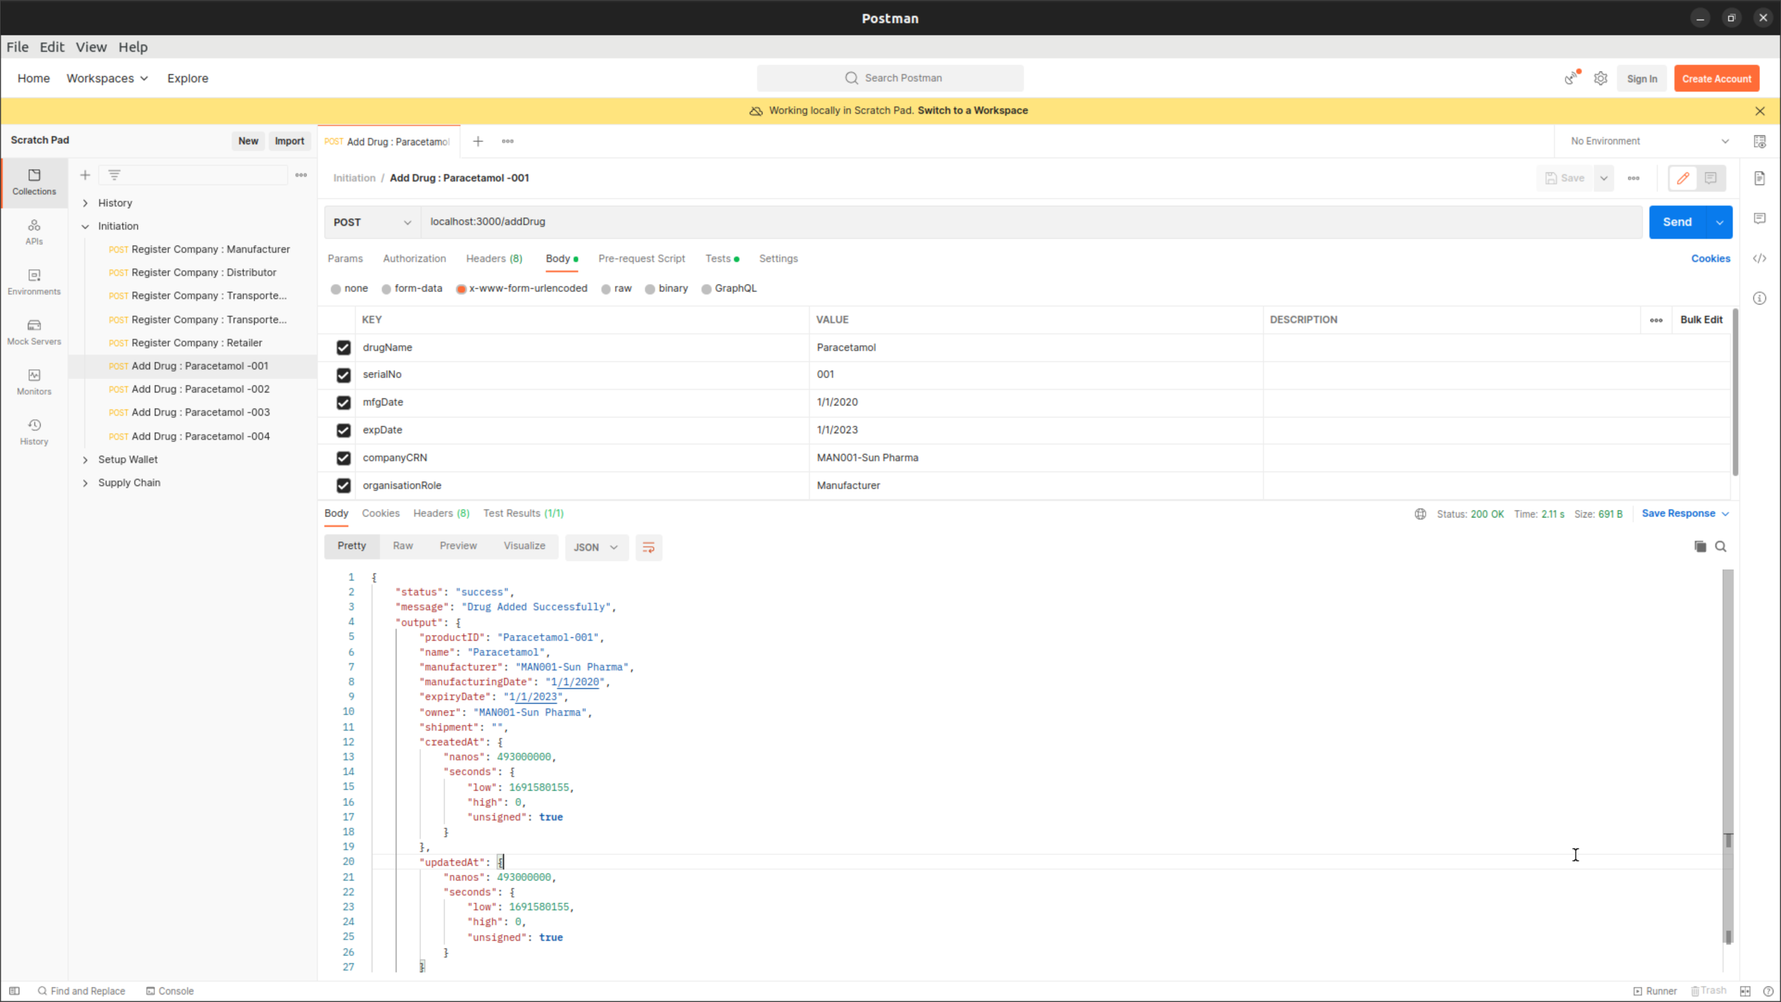

**Screenshot: Console**

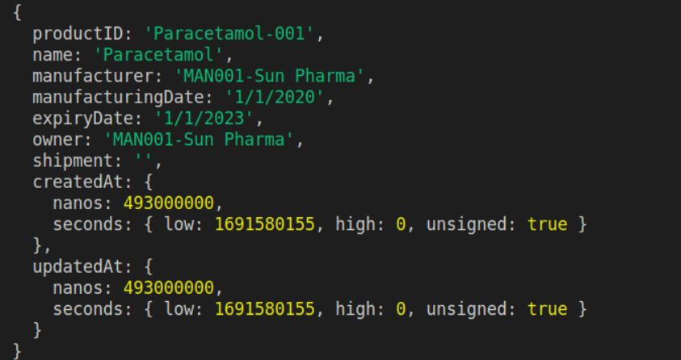

**Add Drug: 002**

**Screenshot: Postman**

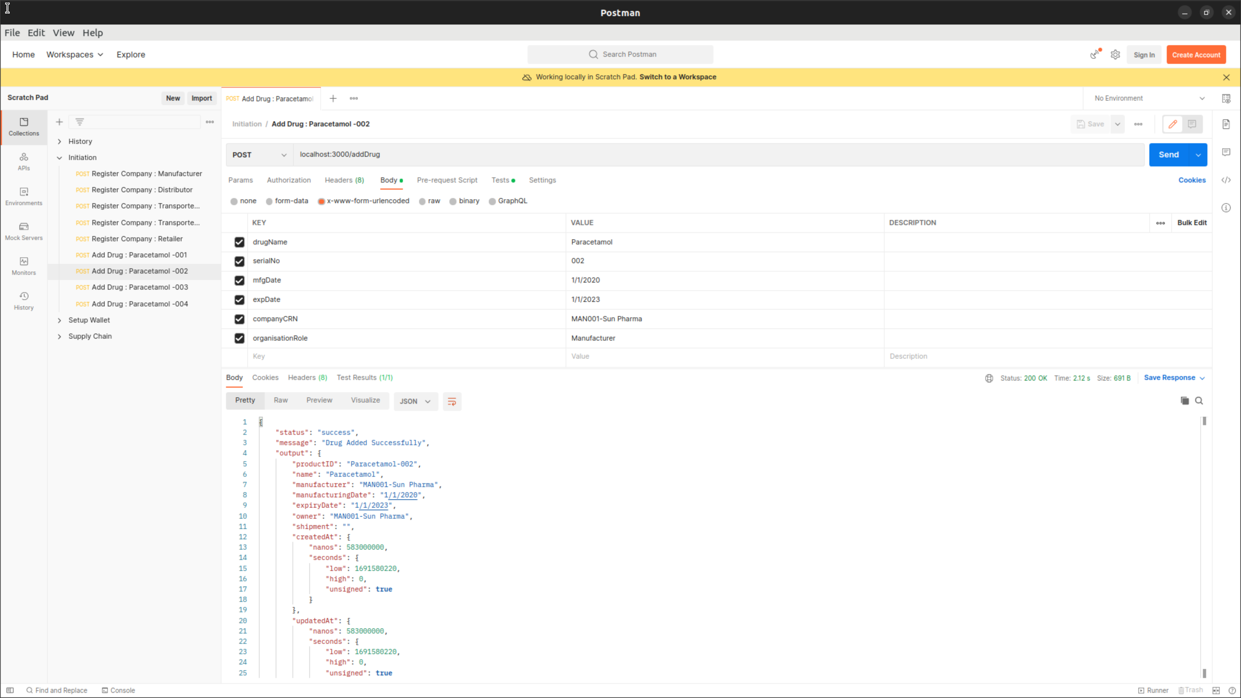

**Screenshot: Console**

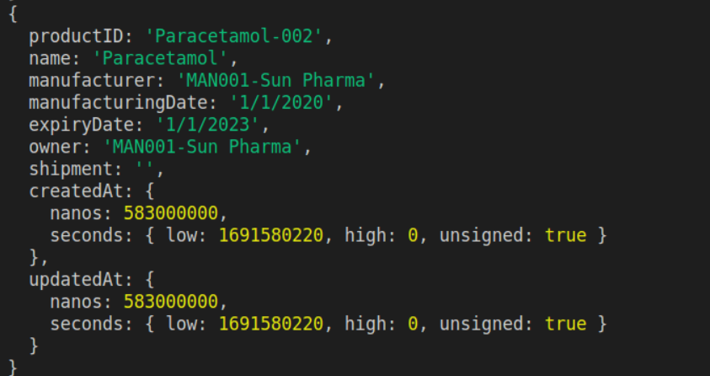

**Add Drug: 003**

**Screenshot: Postman**

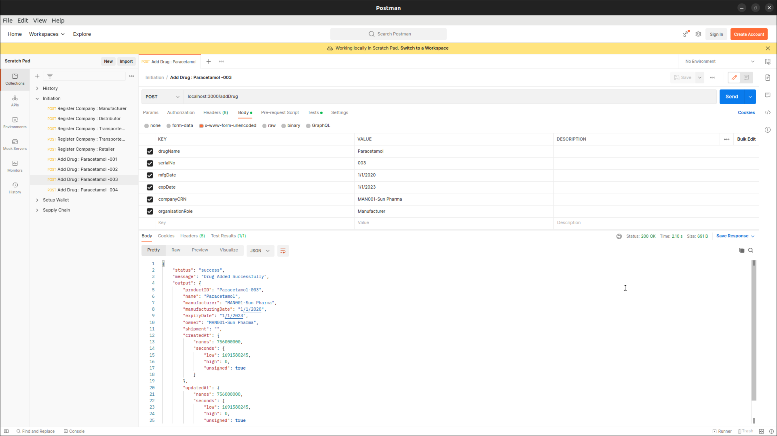

**Screenshot: Console**

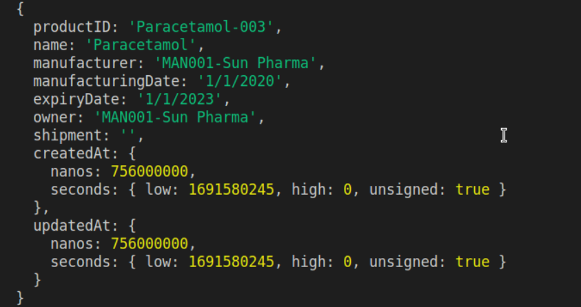

**Add Drug: 004**

**Screenshot: Postman**

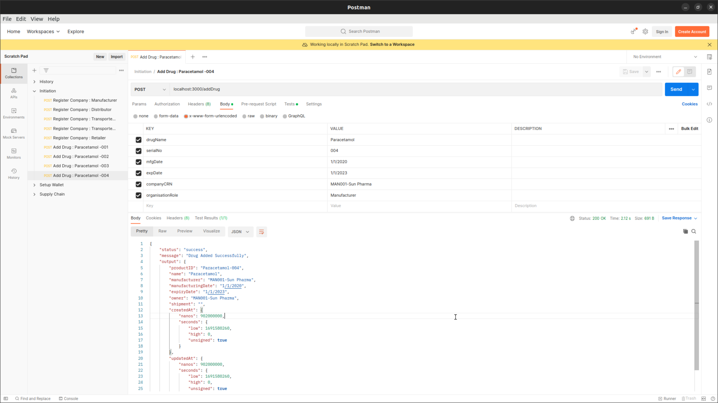

**Screenshot: Console**

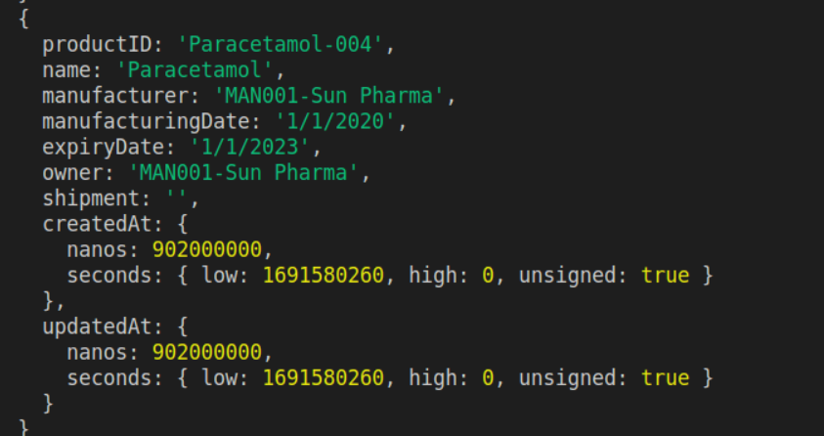

* Once the durg creation is completed we can move forward to perform the supply chain Test Case. The supply chain TC are split into three parts. Open the Supply Chain collection to access the Rest API Calls

* PART A

**Create PO : Distributor to Manufacturer**

**Postman :**

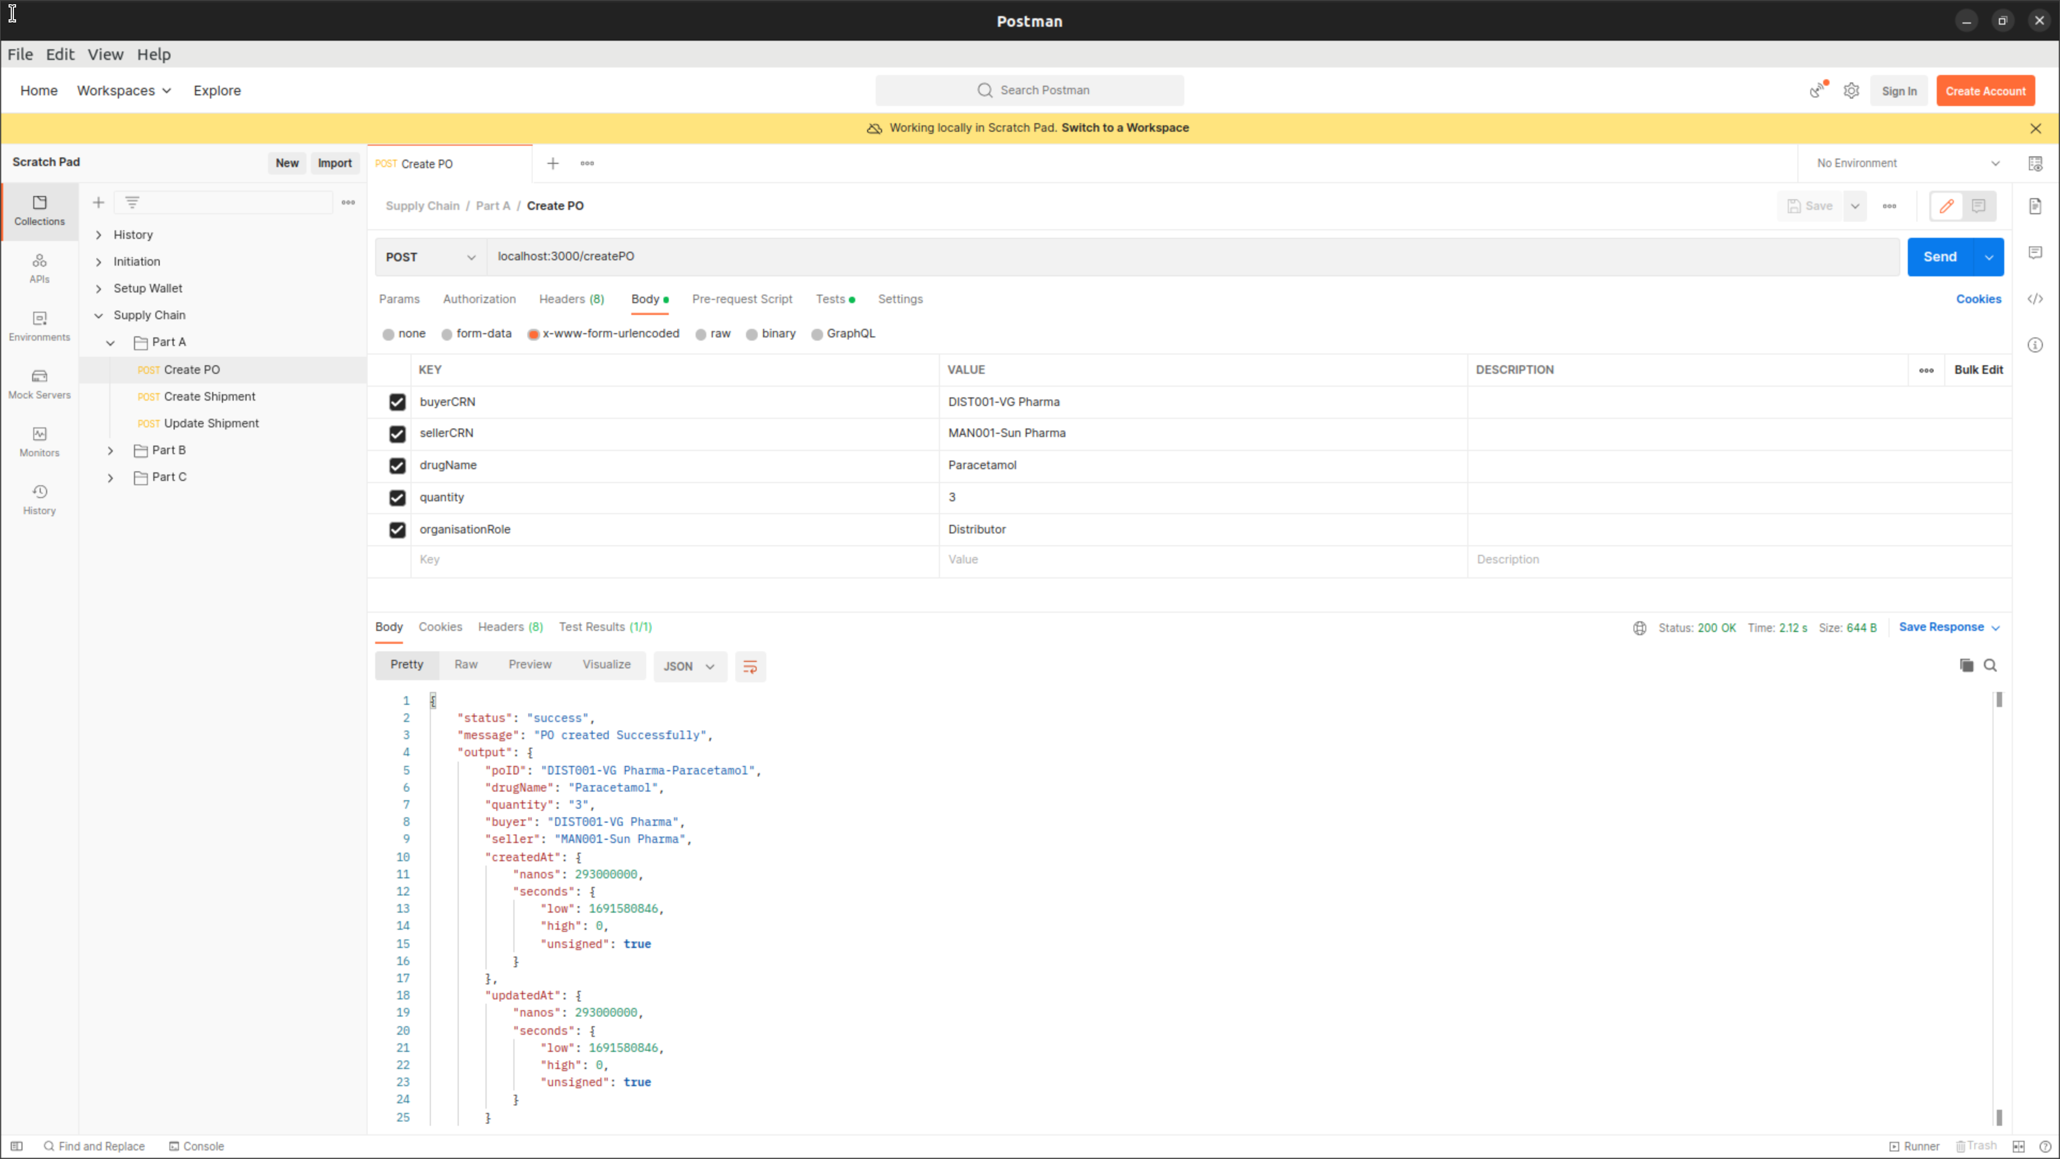

**Console:**

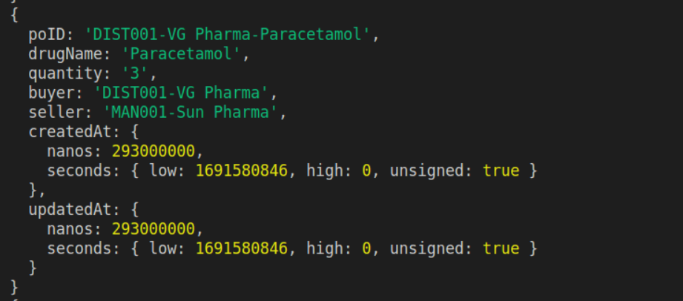

**Create Shipment : Distributor to Manufacturer**

**Postman :**

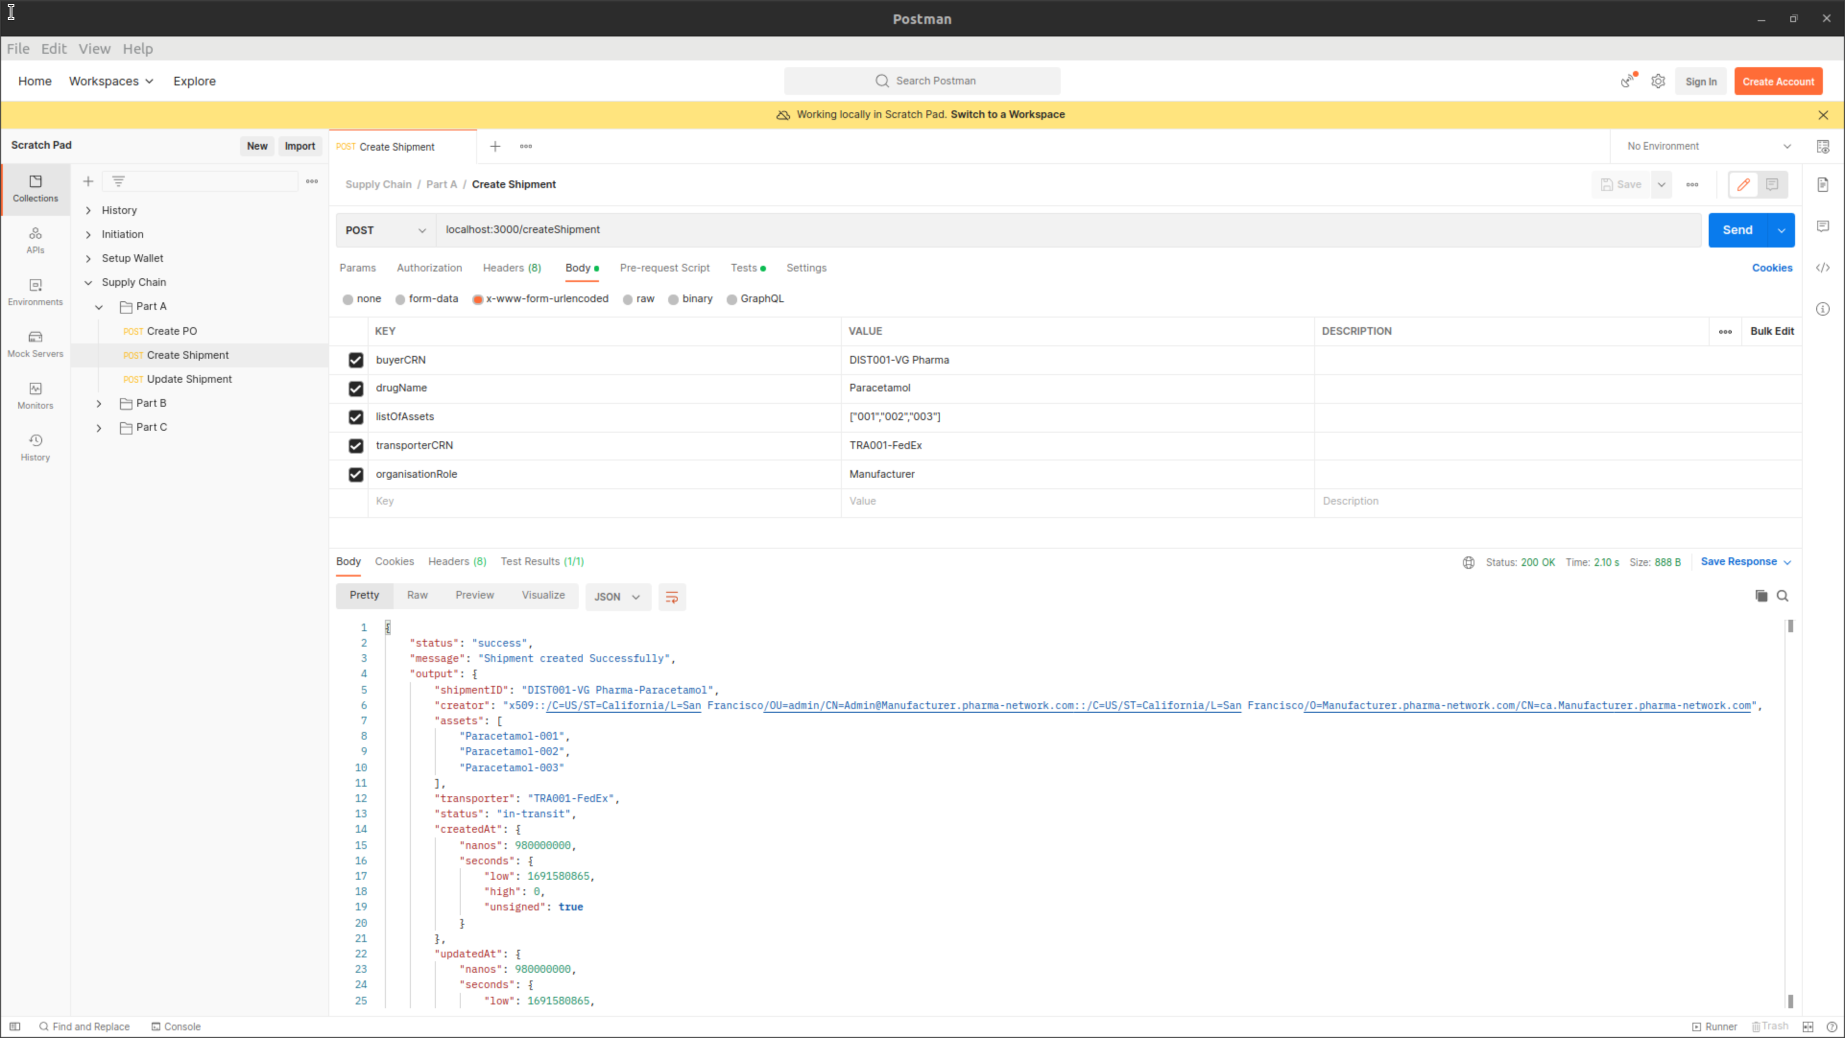

**Console :**

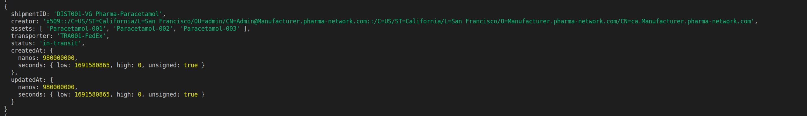

**Create Shipment : Update Shipment**

**Postman :**

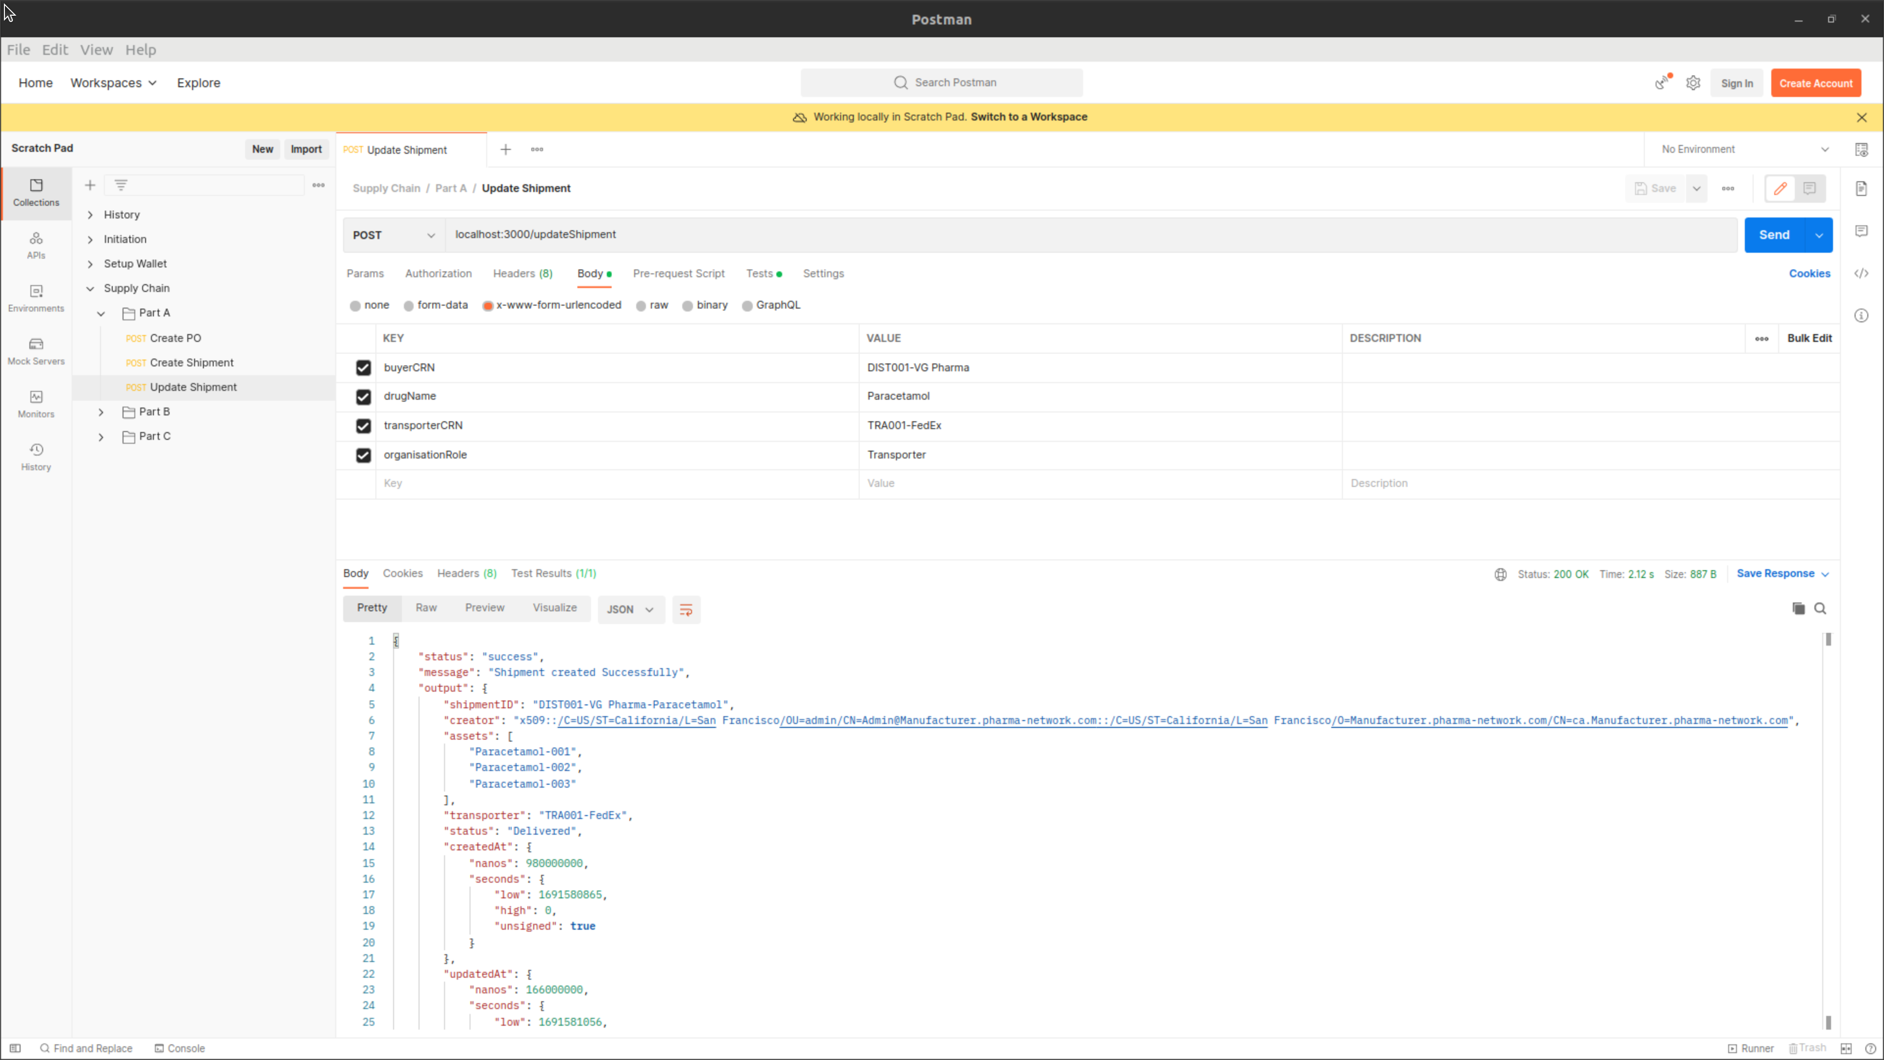

**Console**

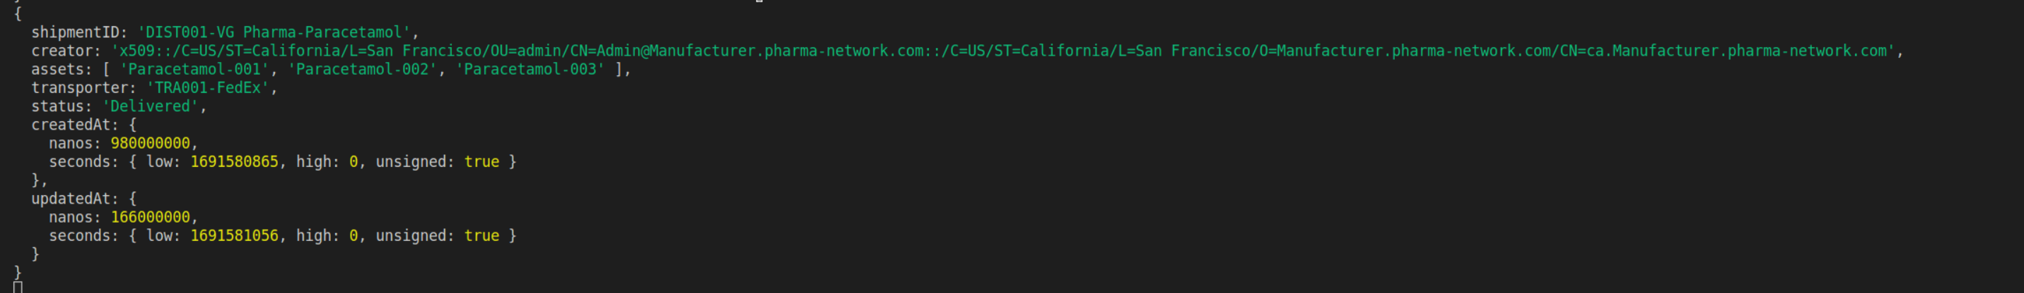

* Part B

**Create PO : Retailer to Distributor**

**Postman :**

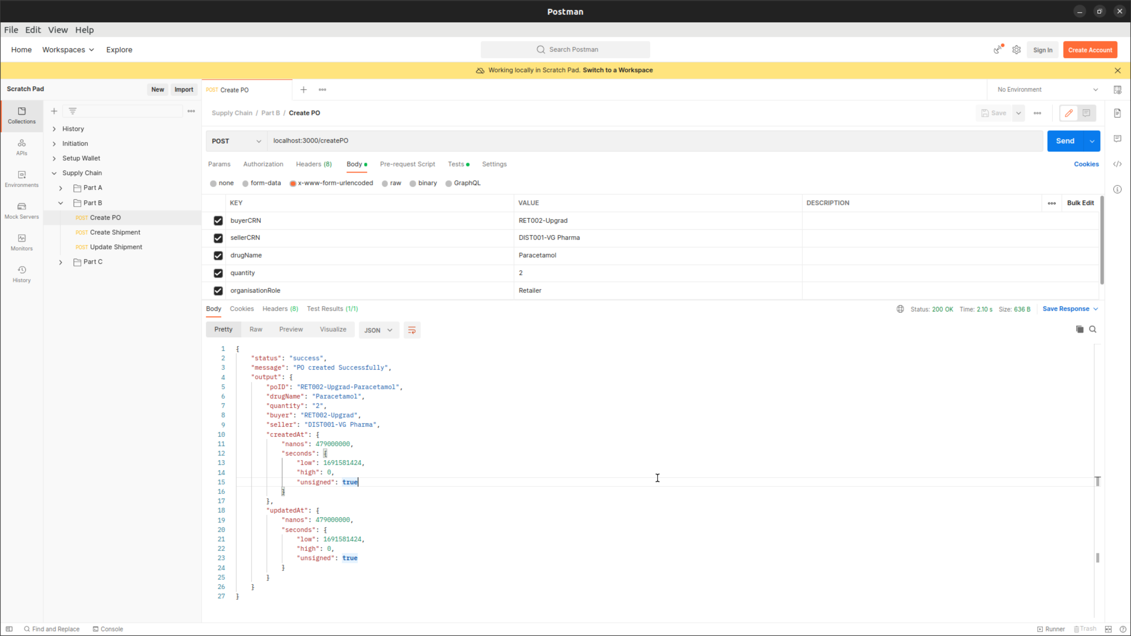

**Console:**

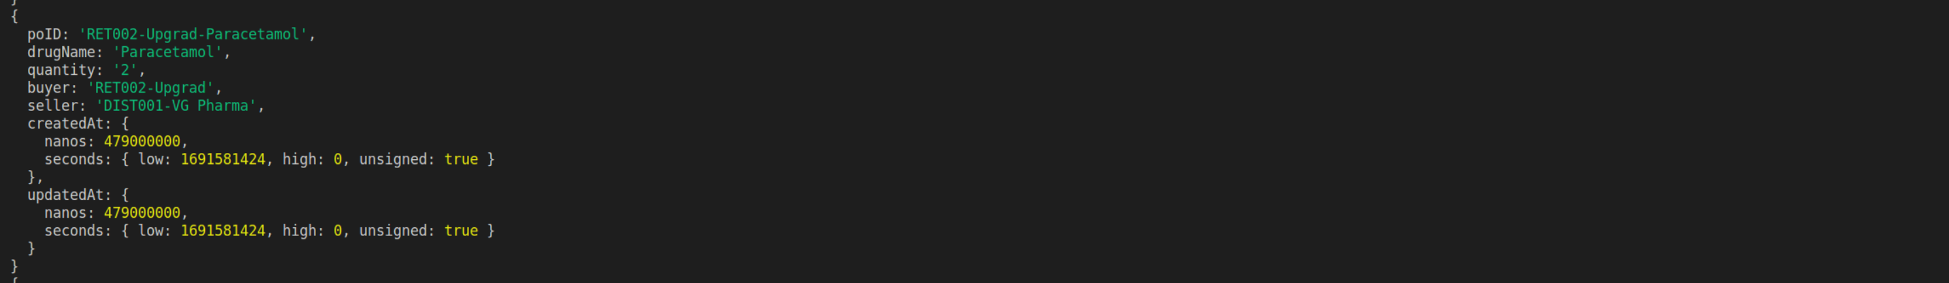

**Create Shipment : Distributor to Retailer**

**Postman :**

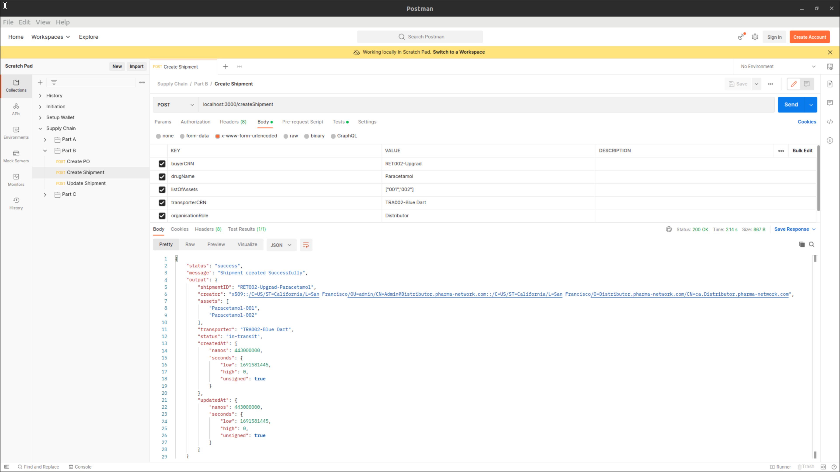

**Console :**

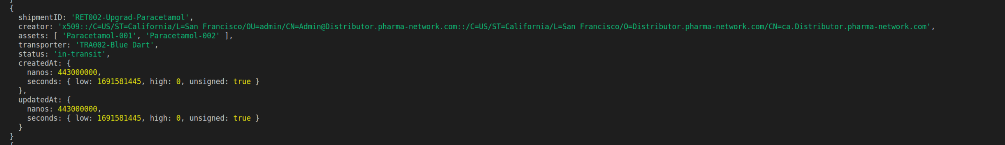

**Update Shipment**

**Postman :**

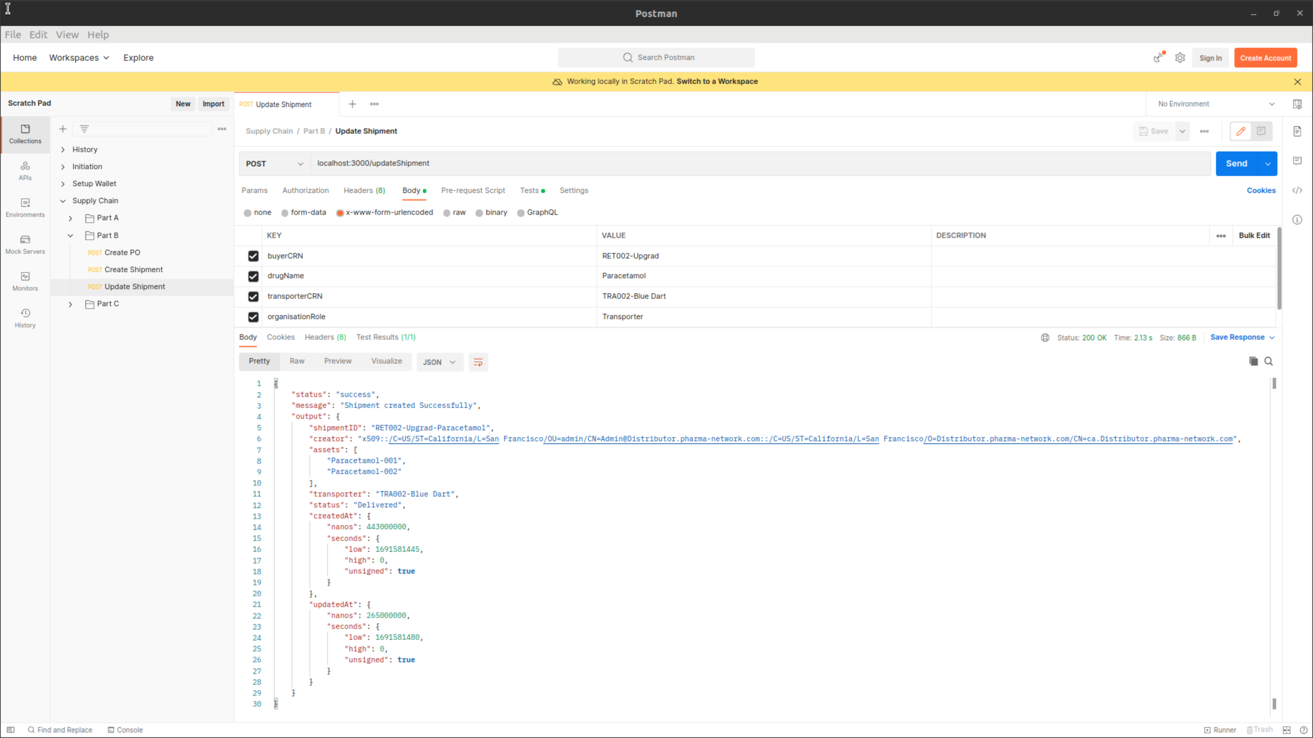

**Console**

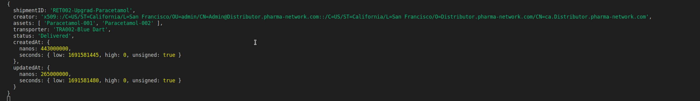

* Part C

**Retail Drug : Update Shipment**

**Postman :**

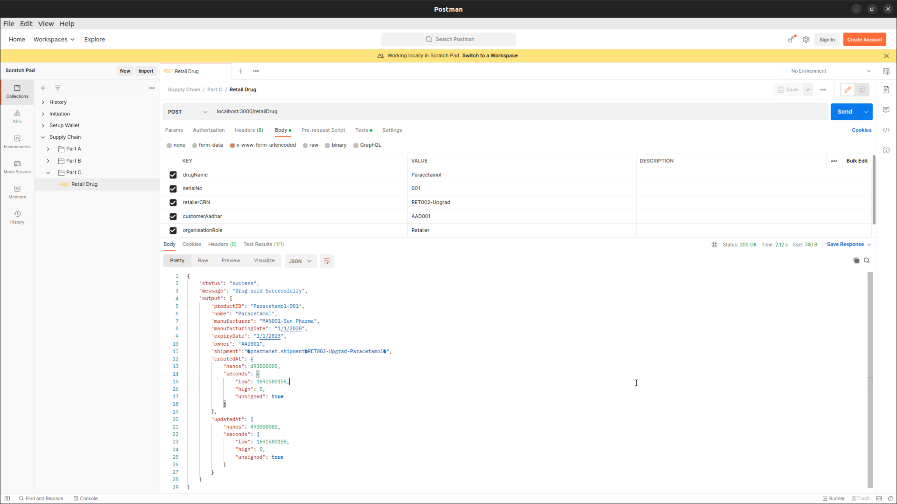

**Console**

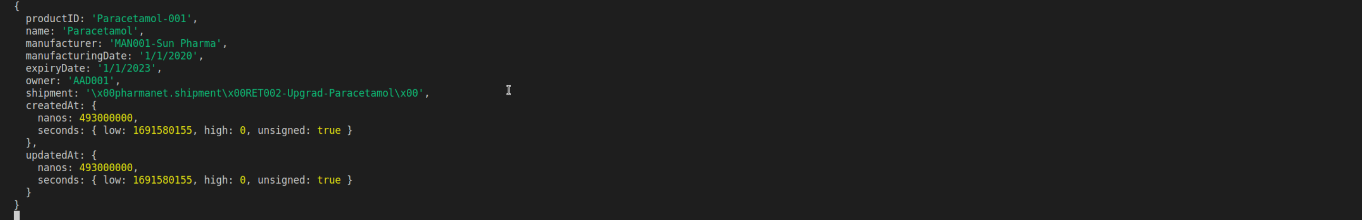

* Once the supply chain is completed we can now view the Drug History

**Postman :**

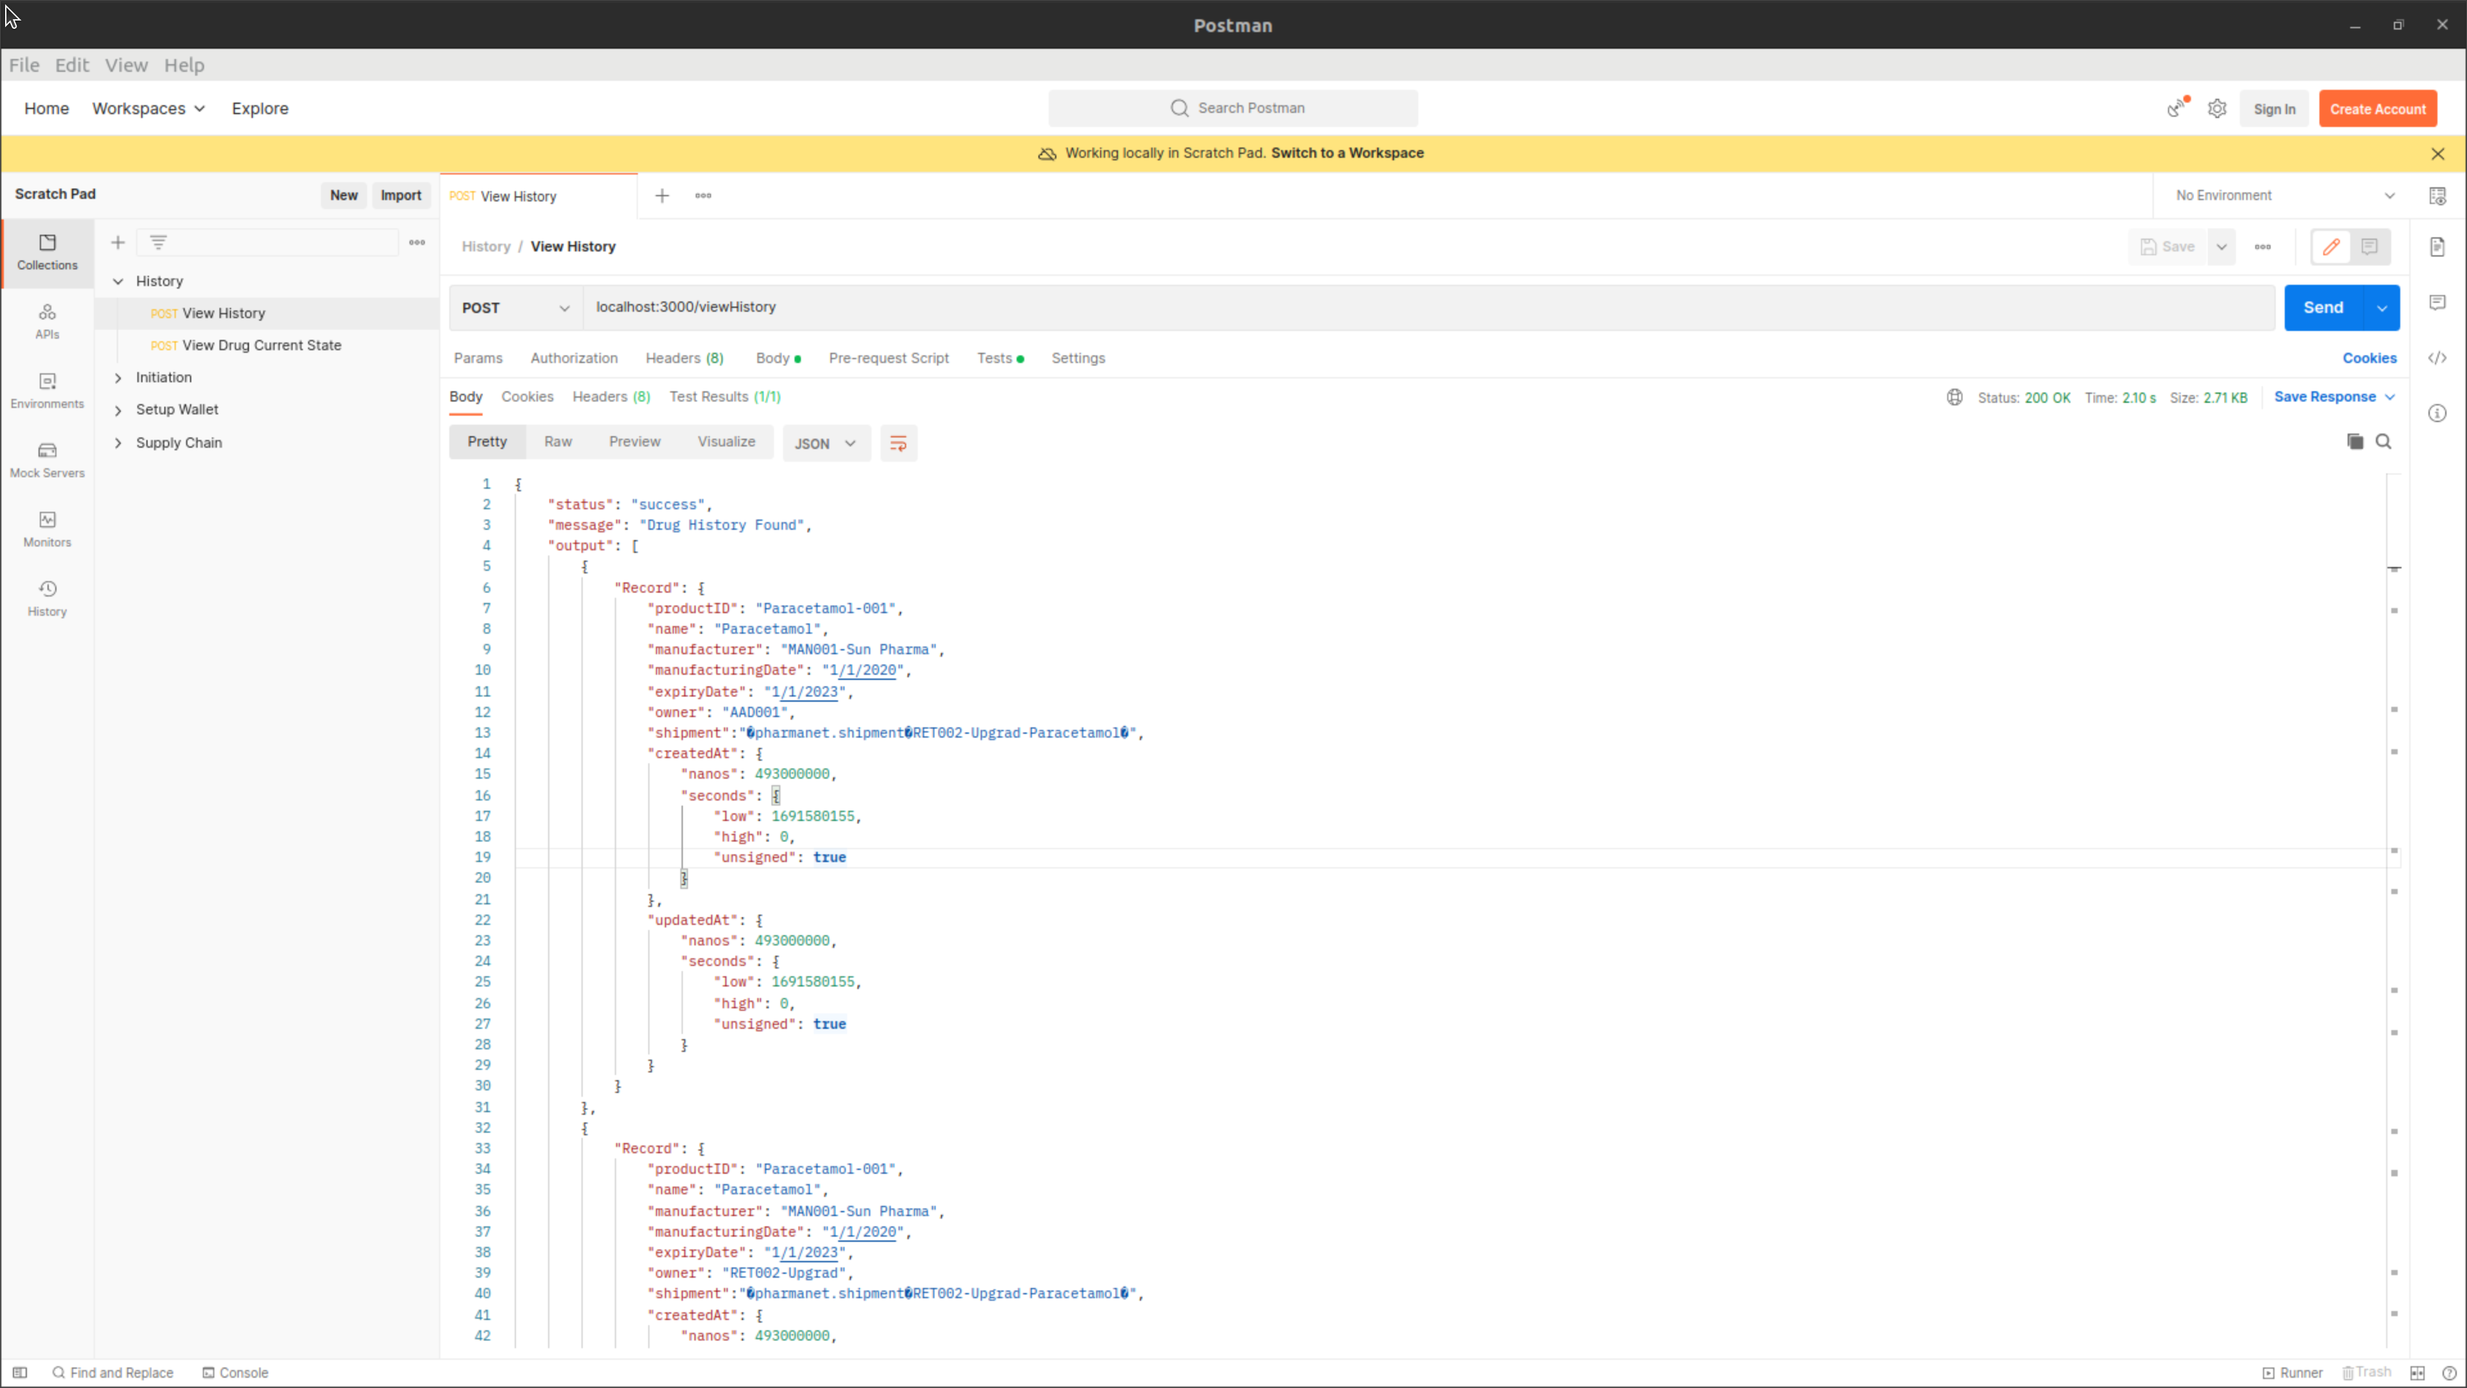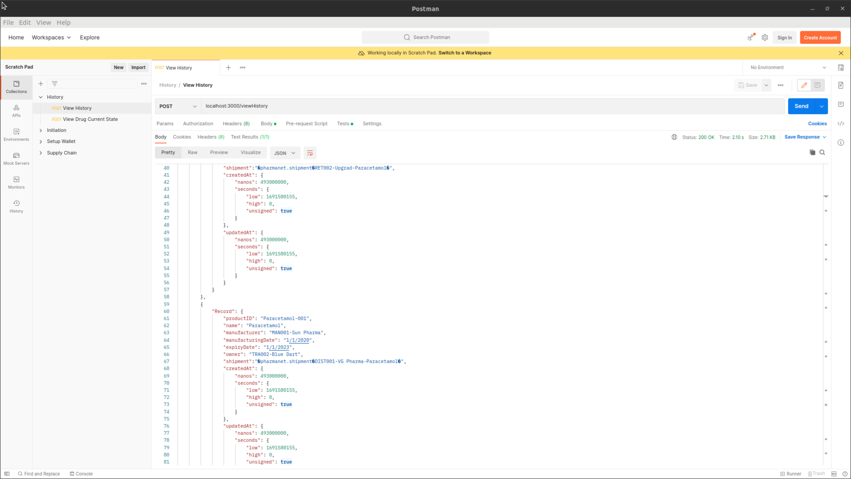

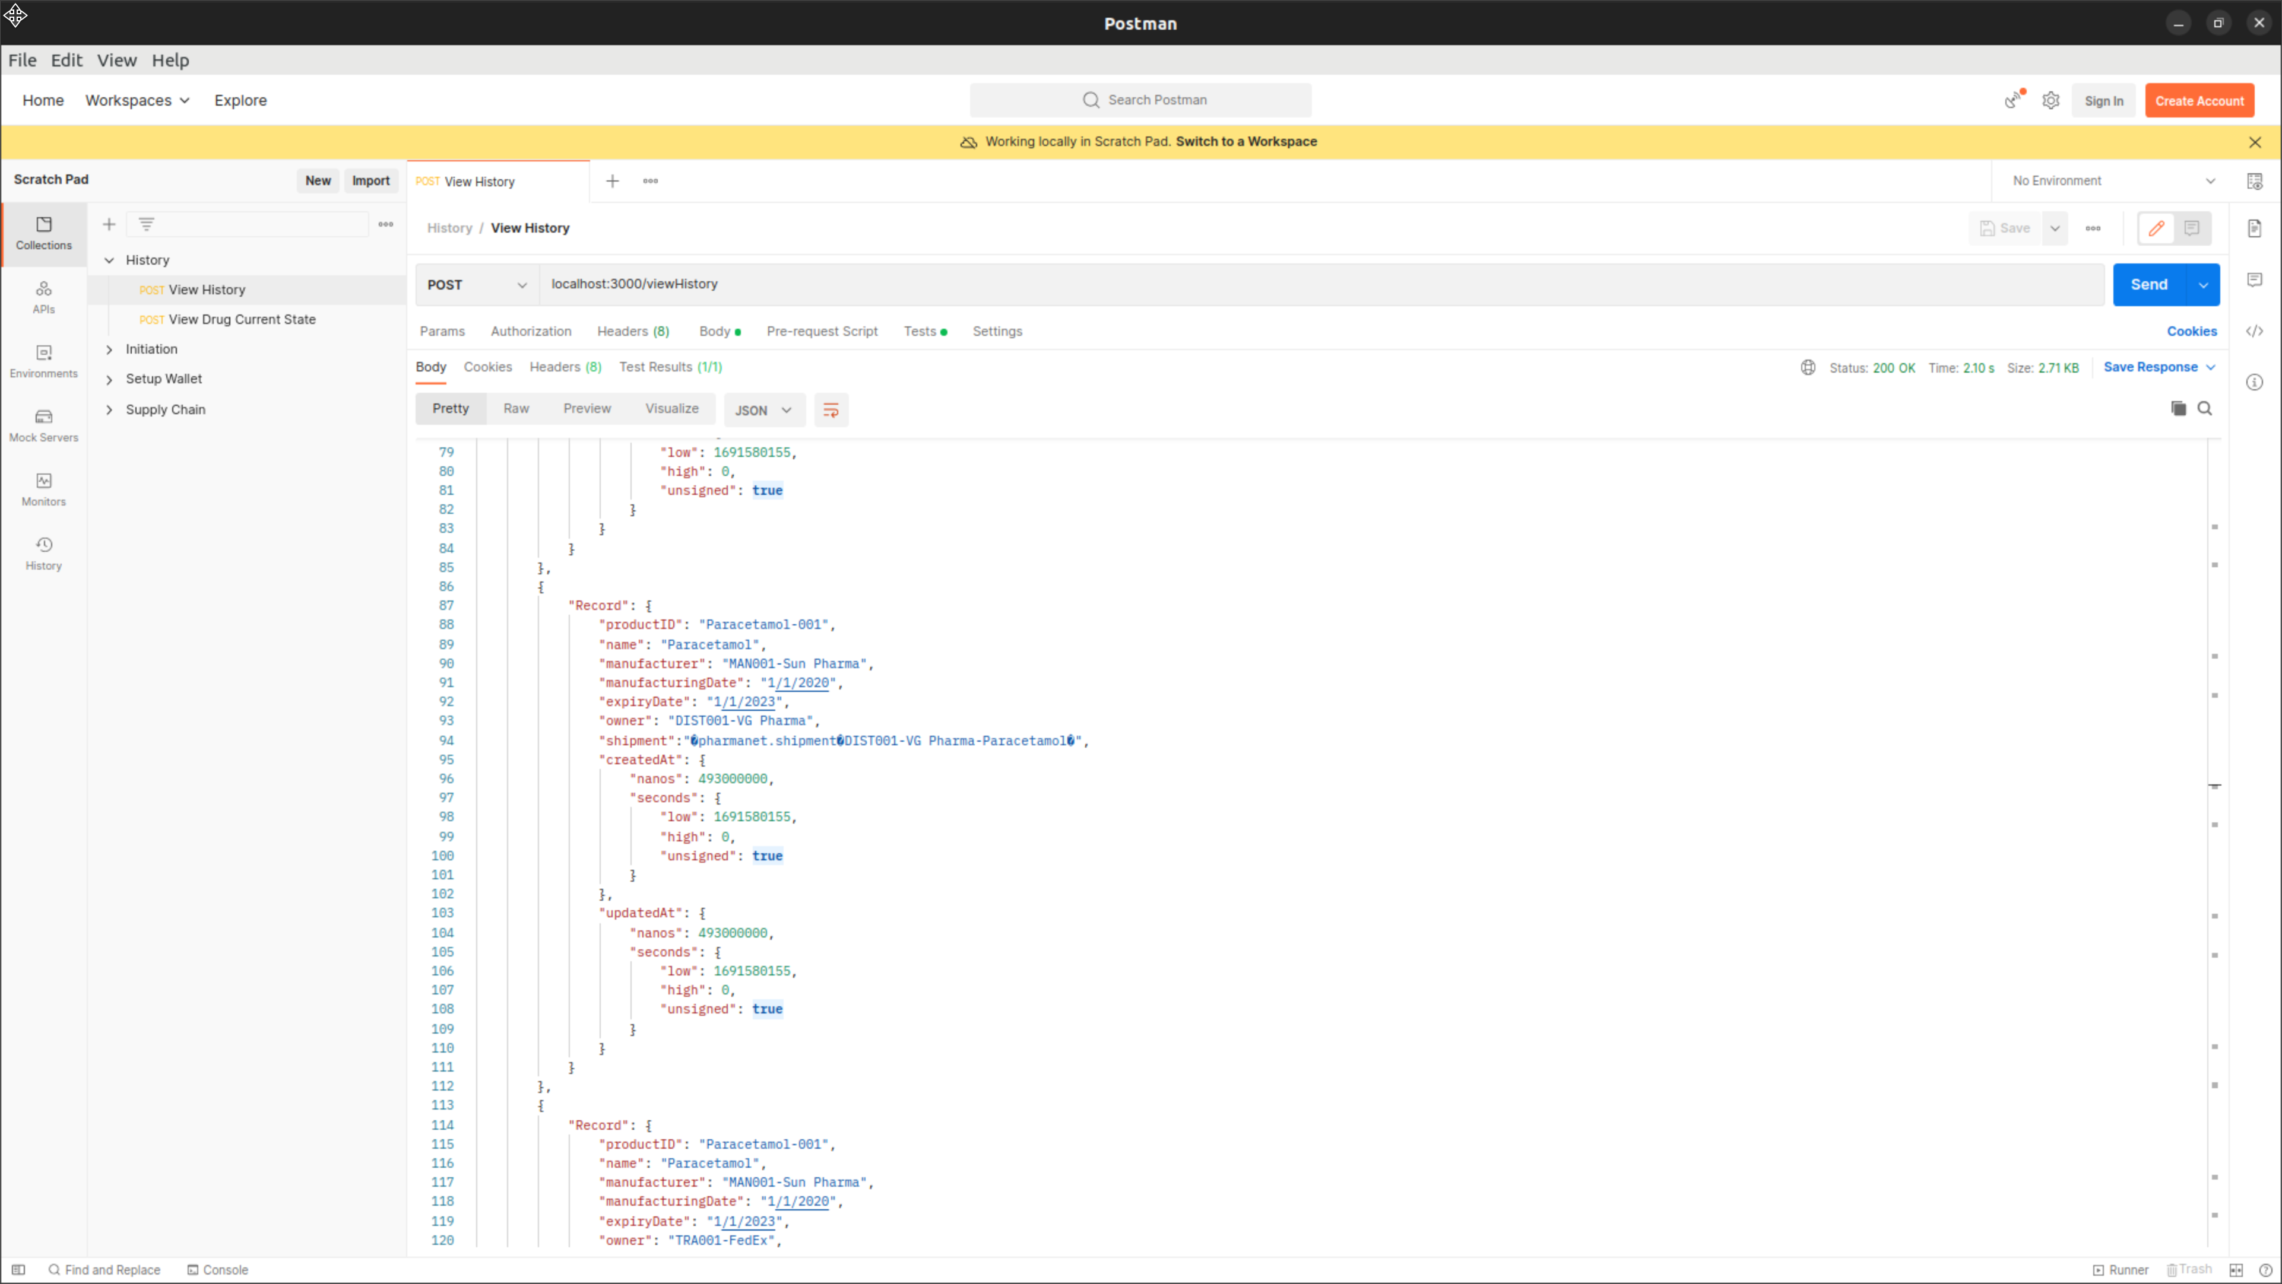

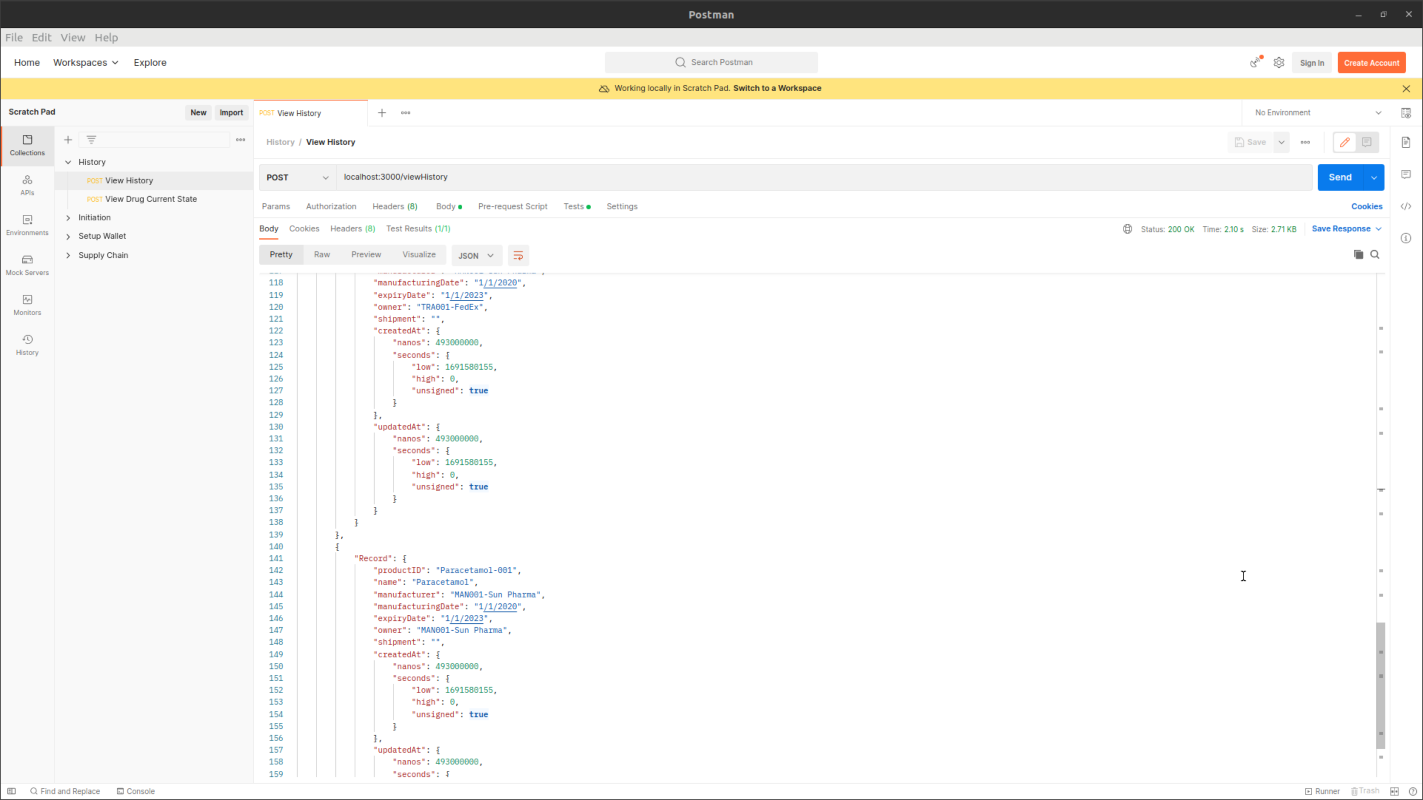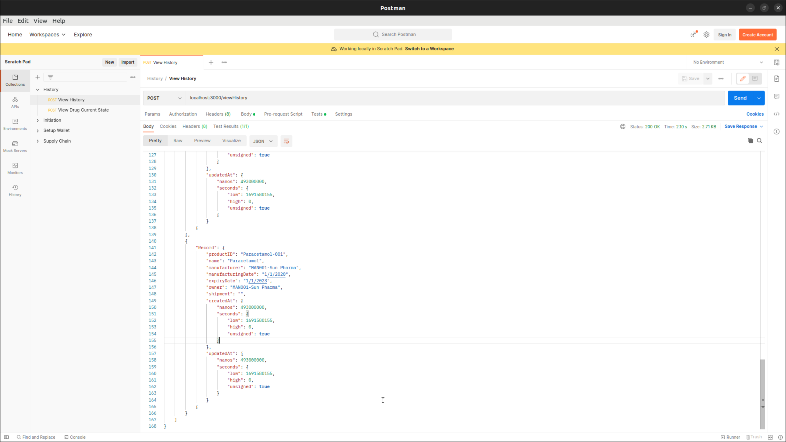

**Console**

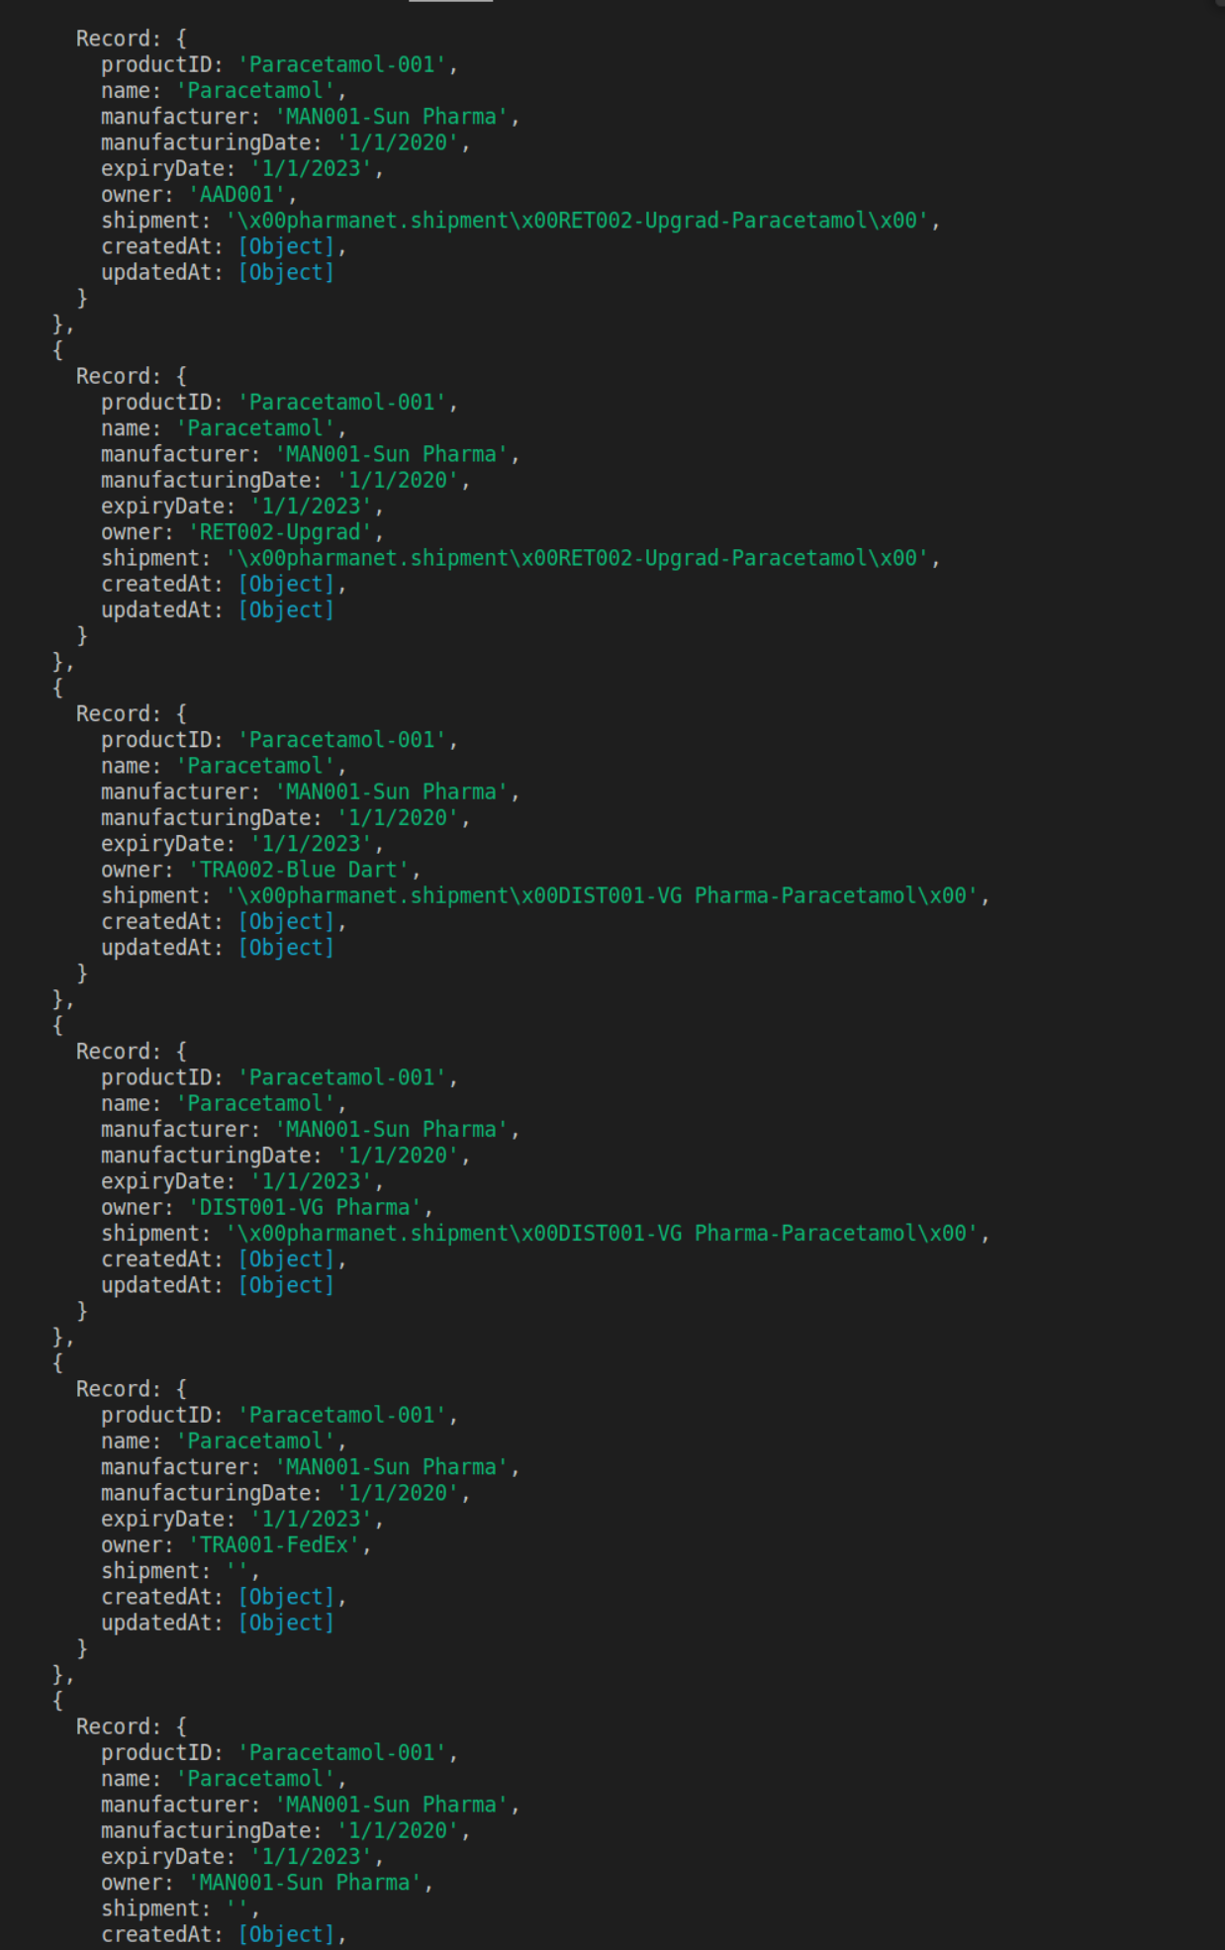

* We can now also view the Drug Current State

**Postman :**

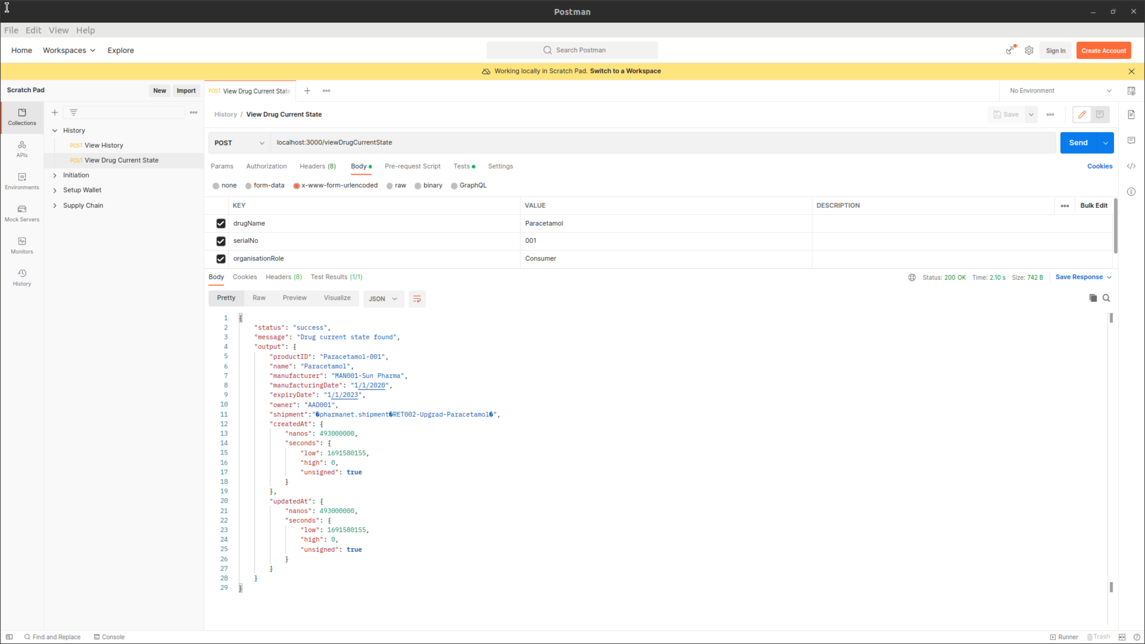

**Console**

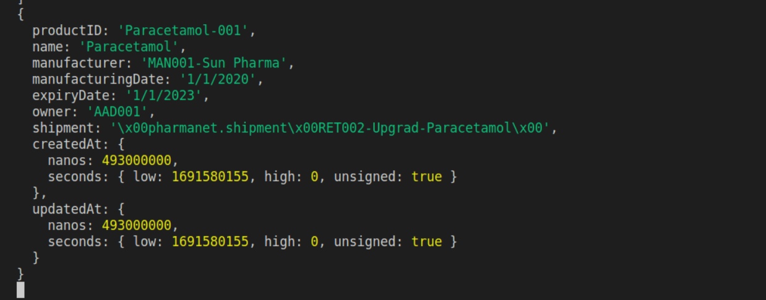

1. **Clearing the setup files to re-launch the network**

To clear the system will all the docker and other crypto materials we can run the following shell script

{Path_to_Project}/pharma-network/test-network-man/clearSetup.sh.

This script will only delete all the files that were created by script {Path_to_Project}/pharma-network/test-network-man/startNetwork.sh

It is recomended that before you run this command, you need to close the client side rest api application.